CSS BRITISH HISTORY · PREDICTION PAPERS
The CSS 2027 Prediction Papers — Sets 1 to 3
Three complete mock papers in the exact CSS format — 60 new MCQs with a key and explanations, 21 predicted questions and short notes, and an answer map and outline for every question

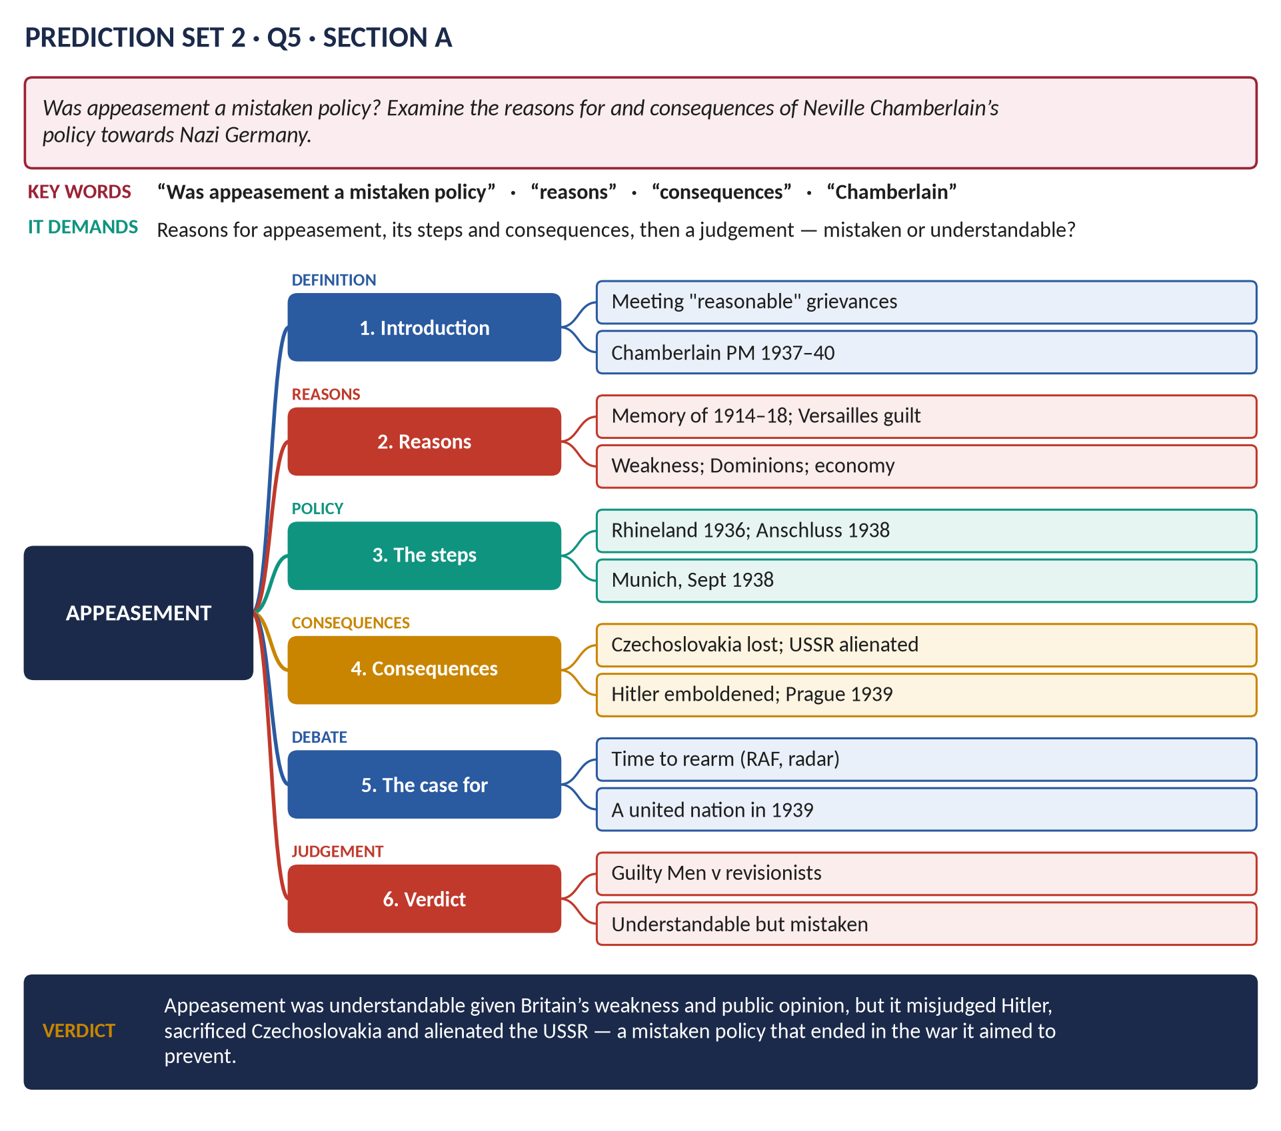
Three full papers built from the 2015–2026 pattern: each set covers all ten topics, favours the themes the examiner has not yet set or is due to repeat, and follows the current layout — Part I (20 MCQs, 30 minutes) and Part II (Section A: 4 questions; Section B: 2 questions + short notes).
Sit each paper under timed conditions, then check the key, the maps and the outlines
Contents
HOW TO USE THIS · Updating the contents
Right-click the contents → Update Field → Update entire table, before saving as PDF.

How These Papers Were Made — and How to Use Them 5
The paper format 5
How the questions were chosen 5
How to use the papers 5
Prediction Set 1 6
Part I · Question 1 — MCQs (20 marks) 6
Part II · Section A (attempt any TWO) 7
Part II · Section B (attempt any TWO) 7
Set 1 · Answer Key — Part I 7
Set 1 · Answer Maps and Outlines 9
Q2 · The Glorious Revolution: Causes and Constitutional Significance 9
Q3 · Pitt the Younger's Domestic and Economic Reforms 10
Q4 · The Repeal of the Corn Laws 12
Q5 · The Liberal Reforms and the Welfare State 13
Q6 · Britain and the EEC, 1957–1975 15
Q7 · The Fall of Margaret Thatcher 16
Q8 · Short Notes — Key Facts 17
(a) The Indian Mutiny of 1857 17
(b) The Beveridge Report 17
(c) The Treaty of Versailles 17
Prediction Set 2 18
Part I · Question 1 — MCQs (20 marks) 18
Part II · Section A (attempt any TWO) 19
Part II · Section B (attempt any TWO) 19
Set 2 · Answer Key — Part I 19
Set 2 · Answer Maps and Outlines 21
Q2 · Sir Robert Walpole: Domestic and Foreign Policy 21
Q3 · The Agricultural Revolution 22
Q4 · Castlereagh and Canning Compared 24
Q5 · Appeasement 25
Q6 · Britain in the Cold War, 1945–1962 26
Q7 · Why Britain Voted to Leave the EU 28
Q8 · Short Notes — Key Facts 29
(a) The Battle of Britain 29
(b) The Miners' Strike of 1984–85 29
(c) Robert Owen (1771–1858) 29
Prediction Set 3 30
Part I · Question 1 — MCQs (20 marks) 30
Part II · Section A (attempt any TWO) 31
Part II · Section B (attempt any TWO) 31
Set 3 · Answer Key — Part I 31
Set 3 · Answer Maps and Outlines 33
Q2 · The Act of Union, 1707 33
Q3 · Britain and the Defeat of Napoleon 34
Q4 · Disraeli: Party and Social Reform 36
Q5 · The Scramble for Africa 37
Q6 · The War Conferences and the United Nations 39
Q7 · Devolution and the Good Friday Agreement 40
Q8 · Short Notes — Key Facts 42
(a) Black Wednesday (1992) 42
(b) The Seven Years' War (1756–1763) 42
(c) Covid-19 and British politics 42

How These Papers Were Made — and How to Use Them

The paper format
Part | Format
Total | 100 marks · 3 hours
Part I | Question 1: 20 MCQs (20 marks) · 30 minutes · answered on the MCQ sheet
Part II | 80 marks · 2 hours 30 minutes · attempt FOUR questions, TWO from each Section
Section A | Questions 2–5 (earlier British history, roughly Topics 1–7) — 20 marks each
Section B | Questions 6–8 (twentieth-century and contemporary Britain, roughly Topics 6–10) — Question 8 is short notes (write on any two, 10 marks each)

How the questions were chosen
1. Every topic appears in every set, in proportion to its weight since 2015.
2. Themes never yet set as full questions are favoured (for example the Corn Laws, Walpole, the Act of Union, appeasement, the EEC, devolution) — the examiner's past habit is to open new ground each year.
3. Due repeats are included where a theme has not appeared for several years.
4. Question shapes follow the examiner's command words: examine, assess, how far, compare, discuss, why.
5. MCQs follow the 2024–26 style — dates, people, treaties and "None of these" when all options are wrong.

How to use the papers
1. Sit Part I in 30 minutes without notes; mark it from the key at the end of each set.
2. Sit Part II in 2 hours 30 minutes: about 35 minutes per answer, 5 minutes planning with a quick answer map.
3. Compare your plan with the answer map and outline for each question; revise the weak areas from the Knowledge Bases named in each outline.
WHAT THE EXAMINER HAS ASKED · A reminder about the MCQs
In recent papers, where none of the three options is correct, the answer is "(D) None of these" — read every option carefully.

Prediction Set 1
NOTE · Instructions
Time allowed: 3 hours. Part I (MCQs) 30 minutes; Part II 2 hours 30 minutes. Maximum marks: 100. Attempt FOUR questions in Part II, selecting TWO from each Section. All Part II questions carry 20 marks.

Part I · Question 1 — MCQs (20 marks)
1. The Bill of Rights was passed in: (A) 1688 · (B) 1689 · (C) 1701 · (D) None of these
2. The Act of Settlement (1701) settled the succession on: (A) the House of Stuart · (B) the House of Orange · (C) Sophia of Hanover and her heirs · (D) None of these
3. Who is generally regarded as Britain's first Prime Minister? (A) Pitt the Elder · (B) Lord North · (C) Robert Walpole · (D) None of these
4. The Seven Years' War was ended by the Treaty of: (A) Utrecht · (B) Aix-la-Chapelle · (C) Versailles · (D) None of these
5. The Act of Union with Ireland came into force in: (A) 1801 · (B) 1798 · (C) 1829 · (D) None of these
6. The Battle of Trafalgar was fought in: (A) 1798 · (B) 1815 · (C) 1805 · (D) None of these
7. The spinning jenny was invented by: (A) Richard Arkwright · (B) Samuel Crompton · (C) Edmund Cartwright · (D) None of these
8. The People's Charter was published in: (A) 1832 · (B) 1838 · (C) 1848 · (D) None of these
9. The Second Reform Act (1867) was carried through the Commons by: (A) Gladstone · (B) Palmerston · (C) Peel · (D) None of these
10. Secret voting was introduced by the Ballot Act of: (A) 1872 · (B) 1867 · (C) 1884 · (D) None of these
11. The Congress of Berlin met in: (A) 1856 · (B) 1884 · (C) 1878 · (D) None of these
12. The Entente Cordiale (1904) was signed between Britain and: (A) Russia · (B) Germany · (C) Japan · (D) None of these
13. The Parliament Act of 1911 limited the power of: (A) the House of Lords · (B) the Crown · (C) the Cabinet · (D) None of these
14. The General Strike took place in: (A) 1921 · (B) 1926 · (C) 1931 · (D) None of these
15. The Munich Agreement was signed in: (A) 1936 · (B) 1939 · (C) 1938 · (D) None of these
16. The National Health Service began in: (A) 1946 · (B) 1951 · (C) 1945 · (D) None of these
17. India and Pakistan became independent in: (A) 1947 · (B) 1945 · (C) 1950 · (D) None of these
18. Britain joined the European Economic Community in: (A) 1963 · (B) 1967 · (C) 1975 · (D) None of these
19. The Falklands War was fought in: (A) 1979 · (B) 1982 · (C) 1990 · (D) None of these
20. The Good Friday Agreement was signed in: (A) 1994 · (B) 2001 · (C) 1998 · (D) None of these

Part II · Section A (attempt any TWO)
Q2. Examine the causes of the Glorious Revolution of 1688 and assess its constitutional significance. (20)
Q3. Assess the domestic and economic reforms of William Pitt the Younger (1783–1801). (20)
Q4. Why were the Corn Laws repealed in 1846, and what were the consequences? (20)
Q5. Discuss the Liberal reforms of 1906–1914. How far did they lay the foundations of the welfare state? (20)

Part II · Section B (attempt any TWO)
Q6. Trace Britain's changing attitude towards the European Economic Community from 1957 to 1975. (20)
Q7. Why did Margaret Thatcher fall from power in 1990? (20)
Q8. Write short notes on any TWO of the following: (10 each)
(a) The Indian Mutiny of 1857 · (b) The Beveridge Report · (c) The Treaty of Versailles

Set 1 · Answer Key — Part I
No. | Answer | Why
1 | B | Passed in December 1689, after the Declaration of Right (February 1689).
2 | C | Sophia, Electress of Hanover, and her Protestant heirs — hence George I (1714).
3 | C | Walpole, First Lord of the Treasury 1721–42.
4 | D | The Treaty of Paris (1763) — none of the options.
5 | A | In force 1 January 1801.
6 | C | 21 October 1805 — Nelson's victory.
7 | D | James Hargreaves (c.1764).
8 | B | May 1838, by William Lovett.
9 | D | Disraeli, for Lord Derby's government.
10 | A | 1872, under Gladstone.
11 | C | June–July 1878, chaired by Bismarck.
12 | D | France — not listed.
13 | A | The Lords lost their veto; only a two-year delay.
14 | B | 4–12 May 1926.
15 | C | 29–30 September 1938.
16 | D | 5 July 1948.
17 | A | 14–15 August 1947.
18 | D | 1 January 1973.
19 | B | 2 April – 14 June 1982.
20 | C | 10 April 1998.

Set 1 · Answer Maps and Outlines

Q2 · The Glorious Revolution: Causes and Constitutional Significance
THE QUESTION · Prediction Set 1 · Q2 · Section A · 20 marks
Examine the causes of the Glorious Revolution of 1688 and assess its constitutional significance.

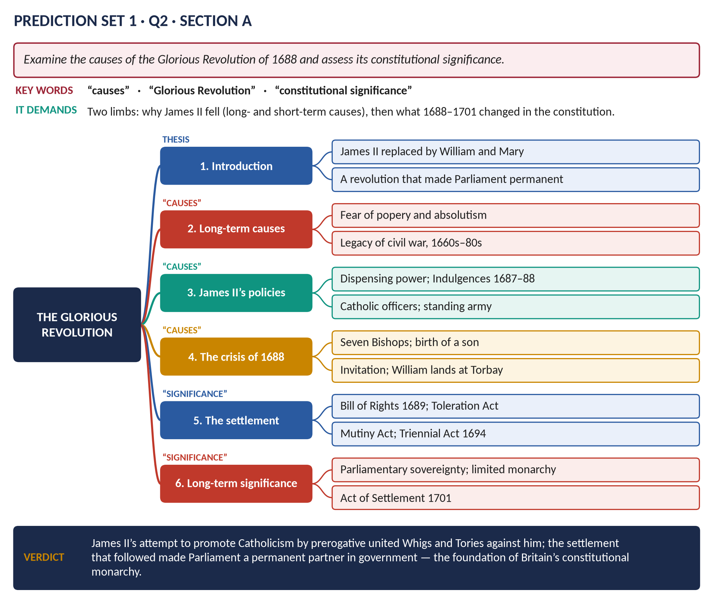
Figure 1 · The answer map.
DECODING THE QUESTION
Two limbs: the causes (long-term fears; James II's policies; the crisis of 1688) and the constitutional significance (the settlement of 1689–1701 and its long-term meaning). "Assess" = judge how important it was.

Key facts to deploy
- James II (1685–88), a Catholic: used the dispensing power to appoint Catholic officers; a standing army of about 34,000 in England (Hounslow Heath); Declarations of Indulgence (1687, 1688); Magdalen College.
- 1688: the Seven Bishops tried and acquitted (June); a Catholic son born (10 June); the invitation to William of Orange (30 June); William landed at Torbay (5 November); James fled (December).
- The settlement: the Declaration of Right (February 1689) and Bill of Rights (December 1689): no suspending or dispensing laws, no taxation or standing army in peacetime without Parliament's consent, free elections and speech in Parliament, no Catholic monarch; the Mutiny Act (1689); the Toleration Act (1689); the Triennial Act (1694); the lapse of censorship (1695); the Act of Settlement (1701).
- Significance: Parliament became permanent and sovereign; limited, constitutional monarchy; the basis of Whig history (Macaulay); Locke's Two Treatises (1689). But: Catholics and Dissenters still excluded; Ireland and Scotland suffered (the Boyne 1690, Glencoe 1692).
- Revise: T1KB.

Q3 · Pitt the Younger's Domestic and Economic Reforms
THE QUESTION · Prediction Set 1 · Q3 · Section A · 20 marks
Assess the domestic and economic reforms of William Pitt the Younger (1783–1801).

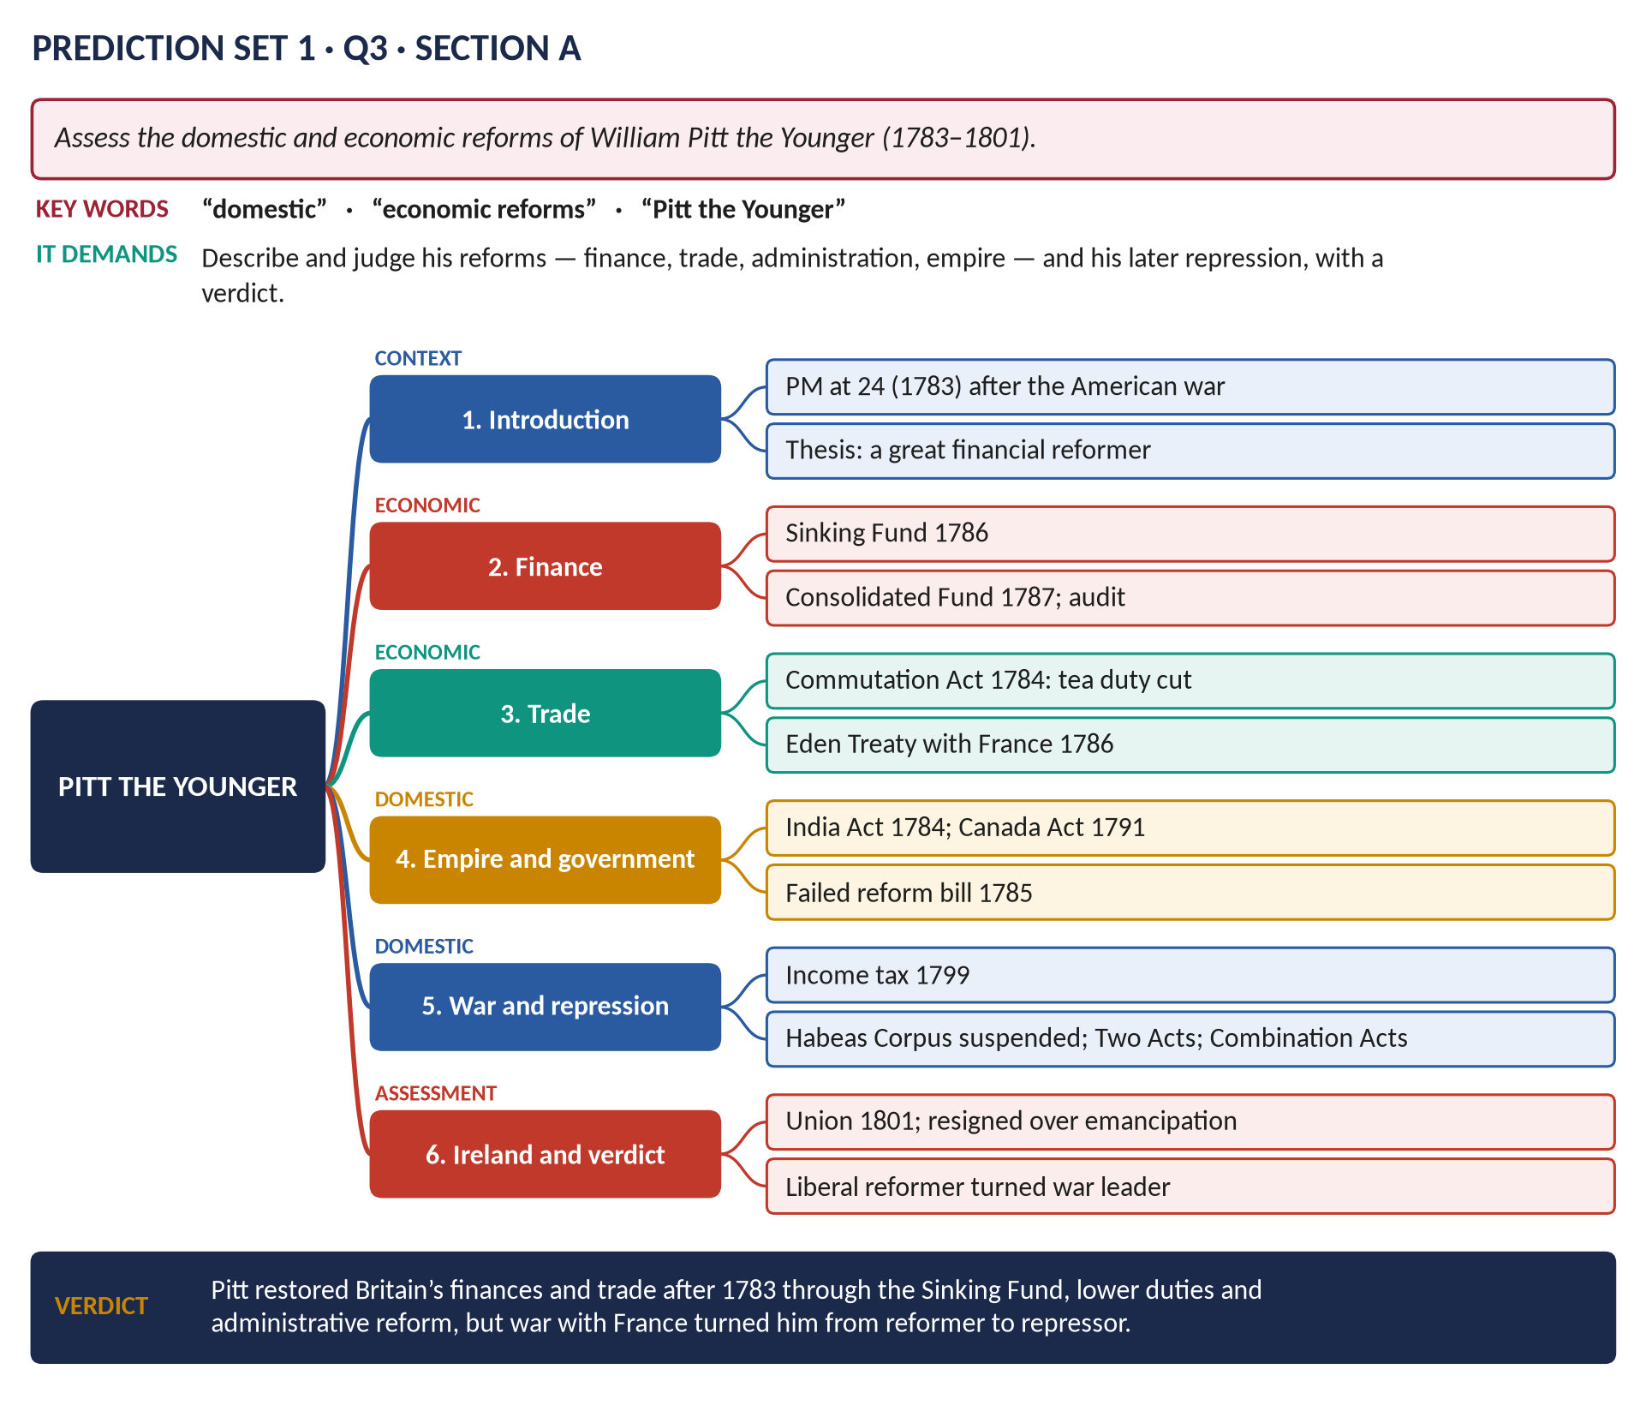
Figure 2 · The answer map.
DECODING THE QUESTION
Describe and judge: finance, trade, administration and empire in peace (1783–93), then the war years (1793–1801) — reform turning to repression.

Key facts to deploy
- PM at 24 (December 1783); won the 1784 election; faced a national debt swollen by the American war.
- Finance: the Sinking Fund (1786) to reduce the debt; the Consolidated Fund (1787); auditing of public accounts; fewer sinecures.
- Trade: the Commutation Act (1784) cut the tea duty from about 119 to 12.5 per cent, killing smuggling; the Eden Treaty with France (1786) cut tariffs (influenced by Adam Smith).
- Empire: the India Act (1784) — the Board of Control; the Canada (Constitutional) Act (1791).
- Failures: his parliamentary reform bill (1785) was defeated; he supported abolition of the slave trade but did not make it government policy.
- War: income tax (1799); repression — Habeas Corpus suspended (1794), the Two Acts (1795), the Combination Acts (1799–1800).
- Ireland: the Act of Union (1800, in force 1801); resigned (1801) when George III refused Catholic Emancipation.
- Revise: T3KB.

Q4 · The Repeal of the Corn Laws
THE QUESTION · Prediction Set 1 · Q4 · Section A · 20 marks
Why were the Corn Laws repealed in 1846, and what were the consequences?

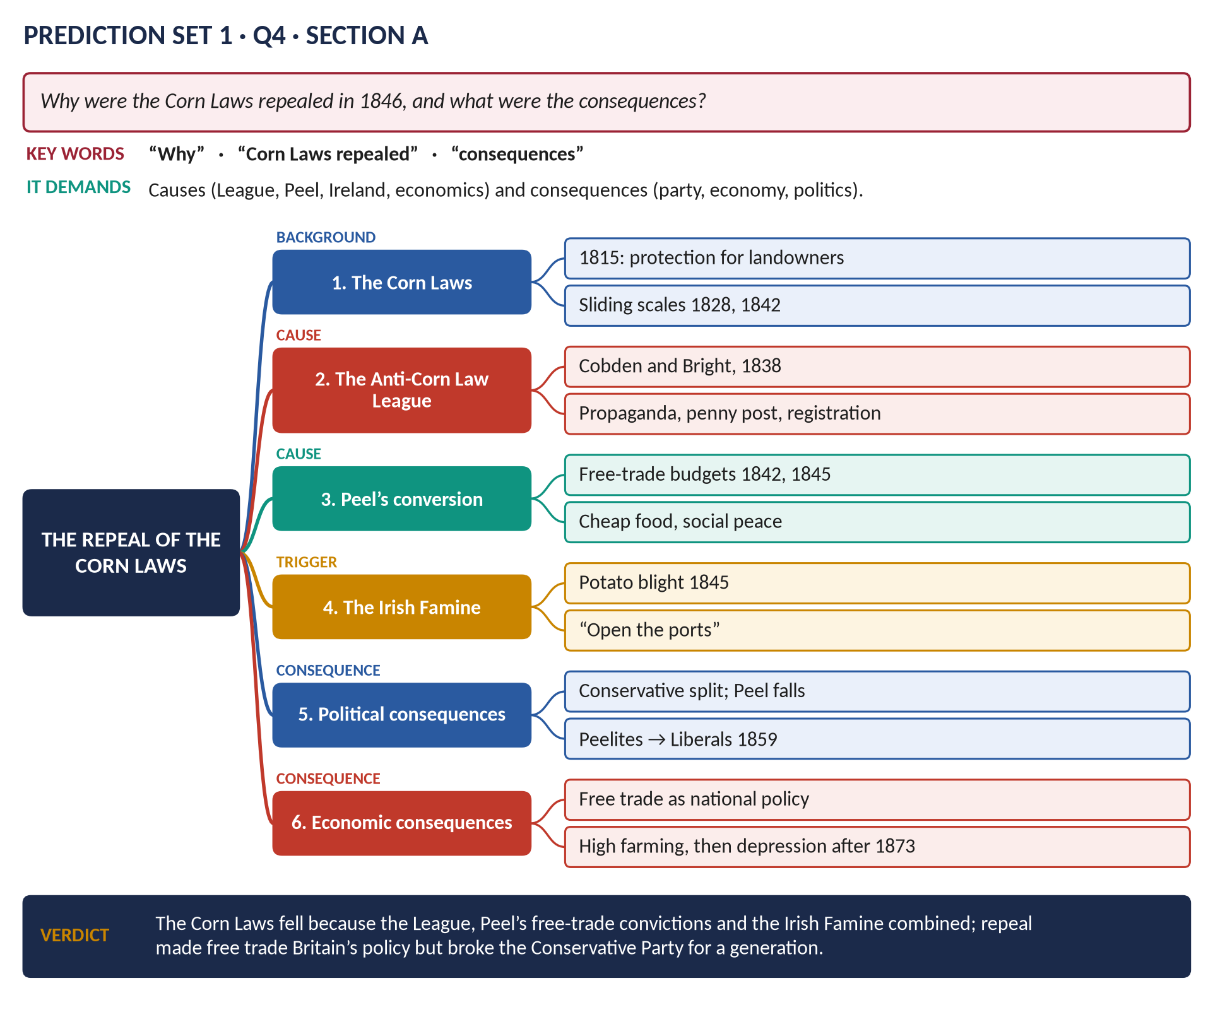
Figure 3 · The answer map.
DECODING THE QUESTION
Causes — the League, Peel, the Famine, economic arguments — then consequences for the party system and the economy.

Key facts to deploy
- The Corn Law (1815) banned foreign wheat below 80 shillings a quarter; sliding scales (1828, 1842).
- The Anti-Corn Law League (1838): Richard Cobden and John Bright; Manchester manufacturers; lecturers, pamphlets via the penny post (1840), registration of free-trade voters.
- Peel's free-trade budgets (1842, 1845); his belief that cheap food meant social peace.
- The Irish potato blight (autumn 1845) — the trigger.
- The vote (May–June 1846): passed with Whig votes; about 231 Conservatives against; Peel defeated on the Irish Coercion Bill (25 June) and resigned.
- Consequences: the Conservative split (Peelites v Protectionists — Derby, Disraeli); no Conservative majority until 1874; the Peelites joined the Liberal Party (1859); free trade national policy until the 1930s; "high farming" (1850–73), then agricultural depression.
- Revise: T5KB Chapter 4.

Q5 · The Liberal Reforms and the Welfare State
THE QUESTION · Prediction Set 1 · Q5 · Section A · 20 marks
Discuss the Liberal reforms of 1906–1914. How far did they lay the foundations of the welfare state?

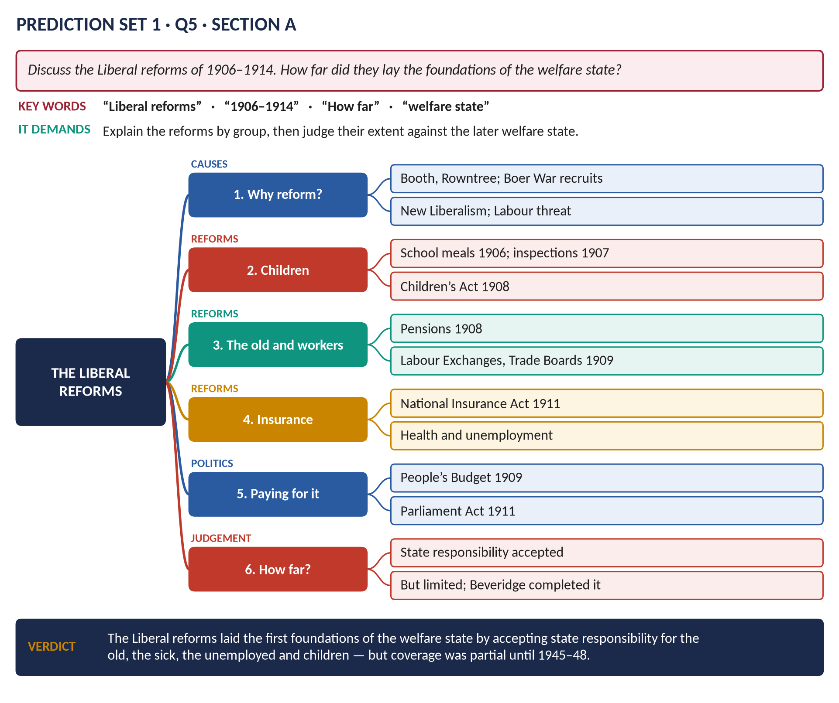
Figure 4 · The answer map.
DECODING THE QUESTION
Discuss the reforms (by group), then judge how far they were the foundations of the later welfare state.

Key facts to deploy
- Why: Booth and Rowntree (1901: ~28% poor in York); Boer War recruits unfit; New Liberalism; national efficiency; the Labour threat; Lloyd George and Churchill.
- Children: free school meals (1906); medical inspections (1907); the Children's Act (1908).
- The old: Old Age Pensions Act (1908) — 5s a week at 70.
- Workers: Trade Disputes Act (1906); Labour Exchanges and Trade Boards (1909).
- The People's Budget (1909) → the Parliament Act (1911).
- National Insurance Act (1911): health (4d + 3d + 2d) and unemployment (7s for 15 weeks).
- How far? The state accepted responsibility for poverty — the principle of the welfare state; but limited coverage (workers only; low pensions); Beveridge (1942) and Attlee (1945–51) built the full system.
- Revise: T7KB Chapter 1.

Q6 · Britain and the EEC, 1957–1975
THE QUESTION · Prediction Set 1 · Q6 · Section B · 20 marks
Trace Britain's changing attitude towards the European Economic Community from 1957 to 1975.

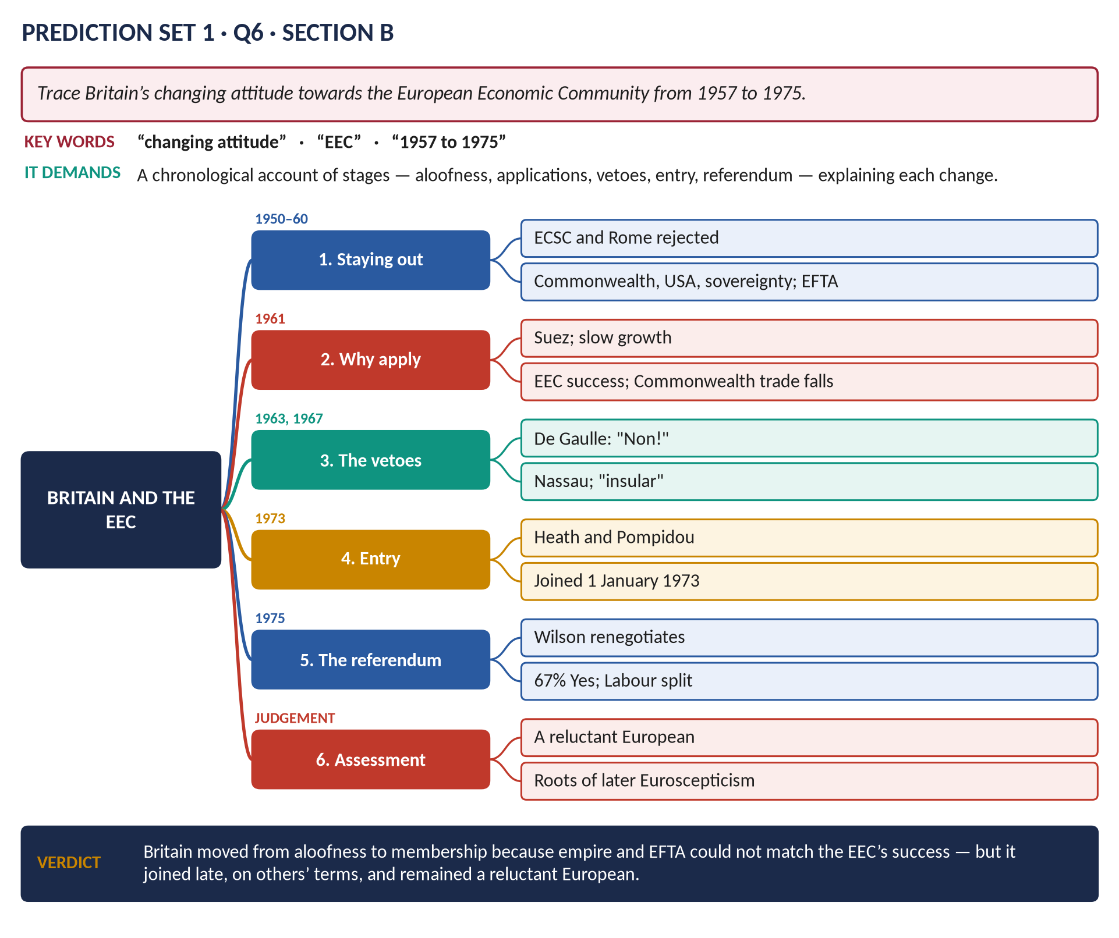
Figure 5 · The answer map.
DECODING THE QUESTION
Trace = a chronological account of changing attitudes, with the reasons for each change.

Key facts to deploy
- Out (1950–60): rejected the ECSC (1951) and the Treaty of Rome (1957) — the Commonwealth, the USA, sovereignty, agriculture; formed EFTA (1960).
- Why apply (1961, Macmillan; negotiator Heath): Suez (1956); slow growth; the EEC's success; falling Commonwealth trade; US encouragement.
- Vetoes: de Gaulle (14 January 1963) — Britain "insular", too close to the USA (Nassau, 1962); Wilson's application vetoed (November 1967).
- Entry: after de Gaulle's resignation (1969), Heath and Pompidou; Britain joined on 1 January 1973 with Ireland and Denmark.
- Referendum (5 June 1975): Wilson's renegotiation; 67 per cent Yes; Labour ministers split.
- Verdict: a reluctant, late European; the roots of later Euroscepticism.
- Revise: T8KB Chapter 10; T9KB Chapter 4.

Q7 · The Fall of Margaret Thatcher
THE QUESTION · Prediction Set 1 · Q7 · Section B · 20 marks
Why did Margaret Thatcher fall from power in 1990?

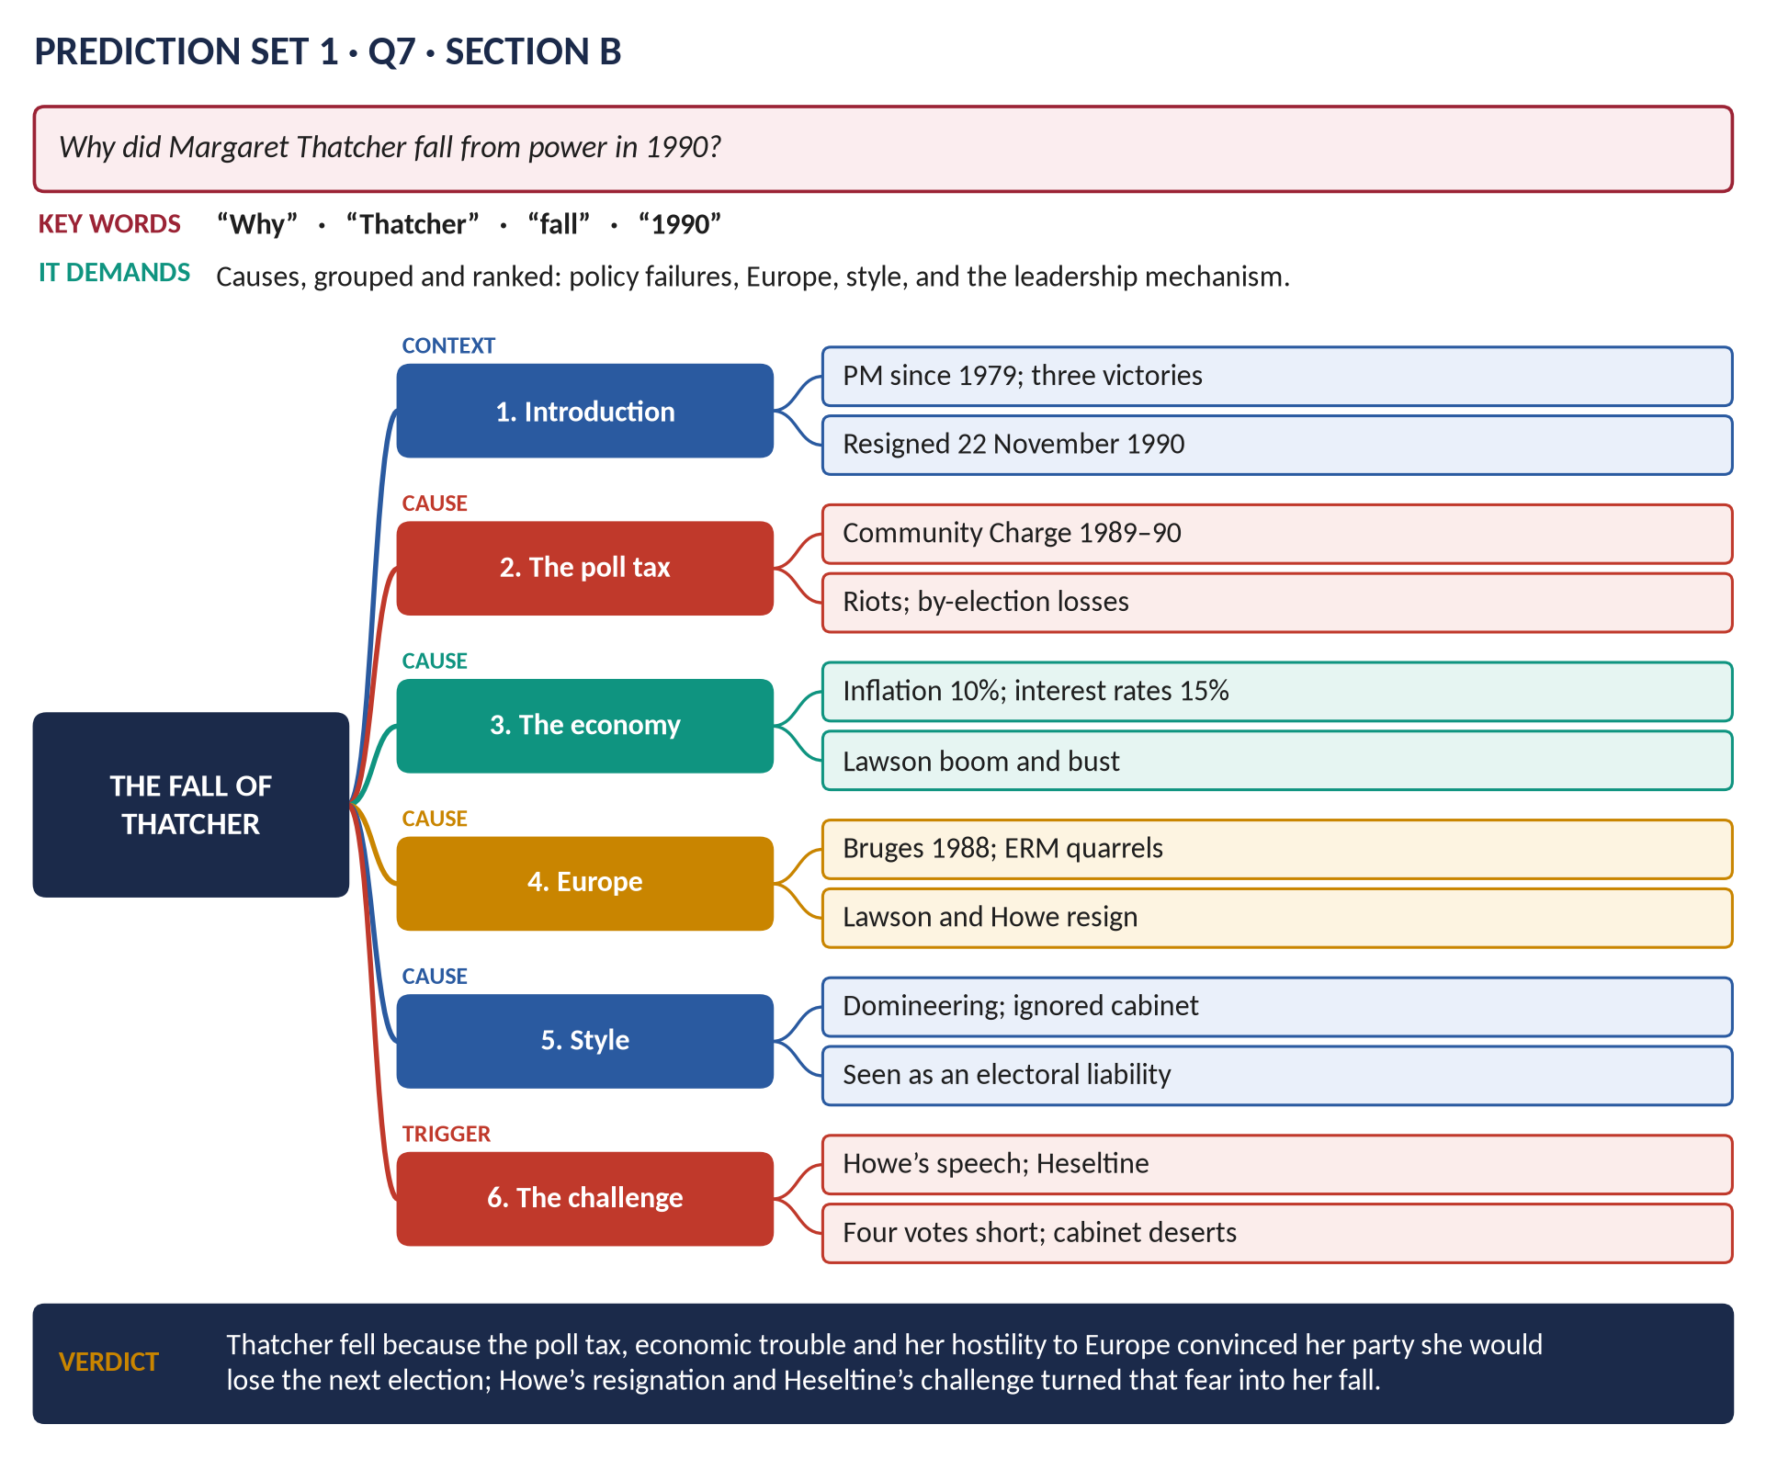
Figure 6 · The answer map.
DECODING THE QUESTION
Why = causes, grouped and ranked — long-term weaknesses and the short-term trigger.

Key facts to deploy
- The poll tax (Community Charge): Scotland 1989, England and Wales April 1990; the riot of 31 March 1990; mass non-payment; by-election defeats (Mid-Staffordshire, Eastbourne).
- The economy: the Lawson boom; inflation back to about 10 per cent; interest rates 15 per cent.
- Europe: the Bruges speech (1988); quarrels over the ERM; Lawson resigned (1989); Howe resigned (1 November 1990) and made his devastating speech (13 November).
- Style: domineering; cabinet colleagues sidelined; seen as an electoral liability (Labour ahead in the polls).
- The contest: Heseltine challenged; Thatcher won 204 to 152 but fell four short of the required margin; cabinet ministers advised her she would lose; she withdrew (22 November 1990); John Major won.
- Revise: T9KB Chapter 1.

Q8 · Short Notes — Key Facts

(a) The Indian Mutiny of 1857
Began at Meerut (10 May 1857); causes — Dalhousie's annexations and the Doctrine of Lapse, the annexation of Awadh (1856), fear of conversion, the greased cartridges; Delhi and Bahadur Shah Zafar; sieges of Lucknow and Cawnpore; atrocities on both sides; Delhi retaken (September 1857). Results: the Government of India Act (1858) — Crown rule, a Secretary of State, a Viceroy; the Queen's Proclamation of religious toleration; army reorganised; the Mughal dynasty ended. (T6KB Chapter 6.)

(b) The Beveridge Report
Social Insurance and Allied Services, published 1 December 1942 by Sir William Beveridge; identified the Five Giants — Want, Disease, Ignorance, Squalor, Idleness; proposed universal, compulsory national insurance "from the cradle to the grave", a national health service, family allowances and full employment; sold over 600,000 copies; the basis of Attlee's welfare state (National Insurance 1946, NHS 1948). (T8KB Chapter 5.)

(c) The Treaty of Versailles
Signed 28 June 1919 in the Hall of Mirrors; the "Big Three" (Wilson, Clemenceau, Lloyd George); Germany lost Alsace-Lorraine, the Polish Corridor and all colonies (mandates); army 100,000, no air force, six battleships; the Rhineland demilitarised; Article 231 (war guilt); reparations £6.6 billion (1921); the League Covenant; Keynes's "Carthaginian peace"; resented in Germany and exploited by Hitler. (T7KB Chapter 6.)

Prediction Set 2
NOTE · Instructions
Time allowed: 3 hours. Part I (MCQs) 30 minutes; Part II 2 hours 30 minutes. Maximum marks: 100. Attempt FOUR questions in Part II, selecting TWO from each Section. All Part II questions carry 20 marks.

Part I · Question 1 — MCQs (20 marks)
1. James II fled from England in: (A) 1685 · (B) 1690 · (C) 1688 · (D) None of these
2. The Battle of the Boyne (1690) was won by: (A) William III · (B) James II · (C) the Duke of Marlborough · (D) None of these
3. Marlborough's great victory of 1704 was the Battle of: (A) Ramillies · (B) Blenheim · (C) Malplaquet · (D) None of these
4. The South Sea Bubble burst in: (A) 1715 · (B) 1745 · (C) 1720 · (D) None of these
5. The Battle of Plassey (1757) was won for the East India Company by: (A) Robert Clive · (B) James Wolfe · (C) Warren Hastings · (D) None of these
6. The American Declaration of Independence was issued in: (A) 1773 · (B) 1776 · (C) 1783 · (D) None of these
7. Britain's youngest Prime Minister, appointed at 24, was: (A) Pitt the Elder · (B) Lord Liverpool · (C) Pitt the Younger · (D) None of these
8. The Battle of Waterloo was fought in: (A) 1805 · (B) 1812 · (C) 1814 · (D) None of these
9. The Methodist movement was founded by: (A) George Whitefield · (B) William Wilberforce · (C) John Wesley · (D) None of these
10. The "Peterloo Massacre" took place in: (A) London · (B) Birmingham · (C) Liverpool · (D) None of these
11. Catholic Emancipation was granted in: (A) 1829 · (B) 1801 · (C) 1832 · (D) None of these
12. The Crimean War was ended by the Treaty of: (A) Berlin · (B) Vienna · (C) Paris · (D) None of these
13. Britain's purchase of the Suez Canal shares in 1875 was arranged by: (A) Gladstone · (B) Disraeli · (C) Palmerston · (D) None of these
14. The Labour Representation Committee was founded in: (A) 1893 · (B) 1906 · (C) 1900 · (D) None of these
15. Britain declared war on Germany in 1914 on: (A) 4 August · (B) 28 June · (C) 1 August · (D) None of these
16. The headquarters of the League of Nations was at: (A) New York · (B) The Hague · (C) London · (D) None of these
17. Britain's Prime Minister during the Battle of Britain was: (A) Neville Chamberlain · (B) Winston Churchill · (C) Clement Attlee · (D) None of these
18. NATO was founded in: (A) 1945 · (B) 1955 · (C) 1949 · (D) None of these
19. The Suez Crisis took place in: (A) 1952 · (B) 1967 · (C) 1973 · (D) None of these
20. The United Kingdom voted to leave the European Union in: (A) 2016 · (B) 2015 · (C) 2020 · (D) None of these

Part II · Section A (attempt any TWO)
Q2. Critically examine the domestic and foreign policy of Sir Robert Walpole (1721–1742). (20)
Q3. Discuss the causes and consequences of the Agricultural Revolution in England. (20)
Q4. Compare the foreign policies of Castlereagh and Canning. (20)
Q5. Was appeasement a mistaken policy? Examine the reasons for and consequences of Neville Chamberlain's policy towards Nazi Germany. (20)

Part II · Section B (attempt any TWO)
Q6. Explain Britain's role in the Cold War from 1945 to 1962. (20)
Q7. Why did Britain vote to leave the European Union in 2016? (20)
Q8. Write short notes on any TWO of the following: (10 each)
(a) The Battle of Britain · (b) The Miners' Strike of 1984–85 · (c) Robert Owen

Set 2 · Answer Key — Part I
No. | Answer | Why
1 | C | December 1688, after William's landing.
2 | A | 1 July 1690 (Old Style), in Ireland.
3 | B | Blenheim, 13 August 1704.
4 | C | 1720; Walpole rose to power in its wake.
5 | A | Robert Clive, 23 June 1757.
6 | B | 4 July 1776.
7 | C | December 1783.
8 | D | 18 June 1815.
9 | C | John Wesley (conversion 1738).
10 | D | Manchester (St Peter's Fields, 16 August 1819).
11 | A | The Catholic Relief Act, 1829.
12 | C | Paris, 30 March 1856.
13 | B | Disraeli, November 1875.
14 | C | 27 February 1900.
15 | A | 4 August 1914.
16 | D | Geneva.
17 | B | Churchill (PM from 10 May 1940).
18 | C | 4 April 1949.
19 | D | 1956.
20 | A | 23 June 2016.

Set 2 · Answer Maps and Outlines

Q2 · Sir Robert Walpole: Domestic and Foreign Policy
THE QUESTION · Prediction Set 2 · Q2 · Section A · 20 marks
Critically examine the domestic and foreign policy of Sir Robert Walpole (1721–1742).

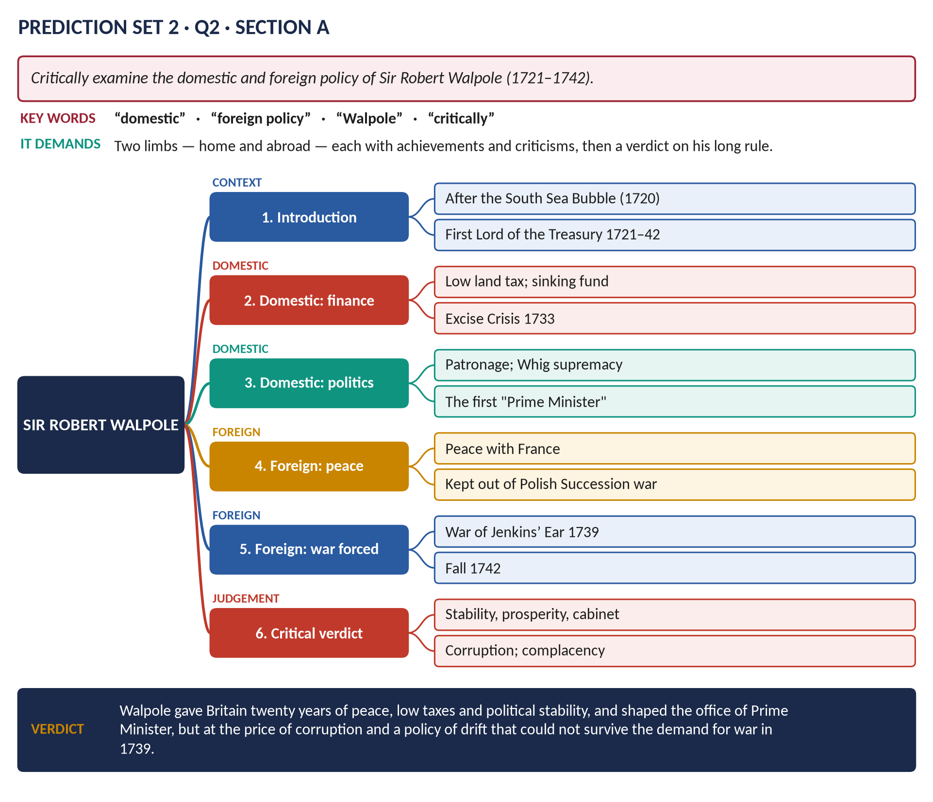
Figure 7 · The answer map.
DECODING THE QUESTION
Two limbs — domestic and foreign — each with achievements and criticisms ("critically"), then an overall verdict.

Key facts to deploy
- Rise: restored confidence after the South Sea Bubble (1720); First Lord of the Treasury and Chancellor from 1721; the favour of George I, George II and Queen Caroline.
- Domestic: low land tax (pleasing the gentry); the sinking fund; encouragement of trade; "let sleeping dogs lie" (quieta non movere); the Excise Crisis (1733) — his scheme withdrawn after an outcry; control through patronage ("Robinocracy"); Whig supremacy; the development of cabinet government and the office of Prime Minister; religious peace (no repeal of the Test Acts).
- Foreign: peace with France (cooperation with Fleury); the Treaty of Seville (1729); kept Britain out of the War of the Polish Succession — "Madam, there are fifty thousand men slain this year in Europe, and not one Englishman"; forced into the War of Jenkins' Ear (1739) by merchants and the "Patriot" opposition.
- Fall: poor war results and election losses; resigned February 1742.
- Criticism: corruption; neglect of the navy and of reform; complacency.
- Revise: T2KB.

Q3 · The Agricultural Revolution
THE QUESTION · Prediction Set 2 · Q3 · Section A · 20 marks
Discuss the causes and consequences of the Agricultural Revolution in England.

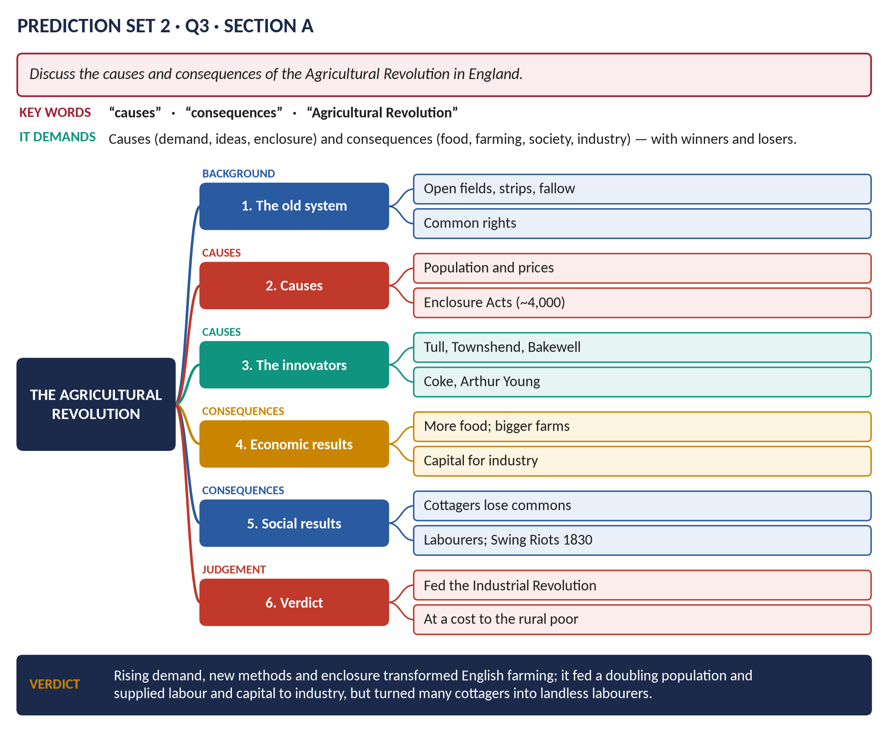
Figure 8 · The answer map.
DECODING THE QUESTION
Causes and consequences — economic and social — with winners and losers.

Key facts to deploy
- The old way: open fields, strips, fallow, commons.
- Causes: population growth and rising grain prices (especially in the French wars); new ideas; enclosure by about 4,000 Acts (1750–1850); General Enclosure Acts 1801, 1845.
- Innovators: Jethro Tull (seed drill); "Turnip" Townshend (Norfolk four-course rotation); Robert Bakewell (selective breeding); Coke of Norfolk; Arthur Young; the Board of Agriculture (1793).
- Economic results: far more food for a population that doubled; bigger, efficient farms; landlords' capital for industry.
- Social results: cottagers lost common rights; landless labourers; migration to towns; the Swing Riots (1830).
- Revise: T4KB Chapter 1.

Q4 · Castlereagh and Canning Compared
THE QUESTION · Prediction Set 2 · Q4 · Section A · 20 marks
Compare the foreign policies of Castlereagh and Canning.

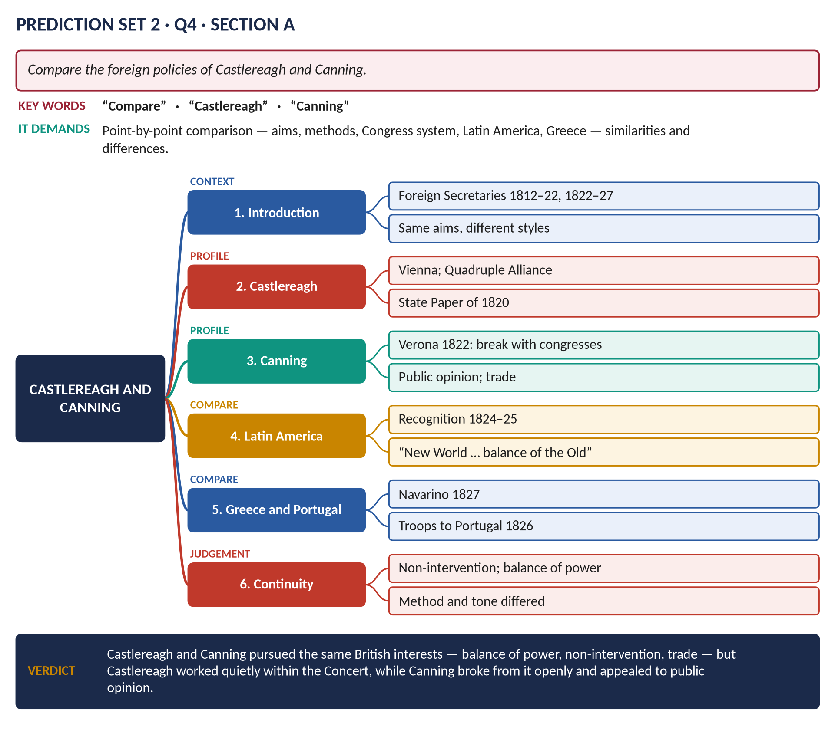
Figure 9 · The answer map.
DECODING THE QUESTION
Compare = similarities and differences, point by point (aims, methods, the Congress system, Latin America, Greece, Portugal), not two separate essays.

Key facts to deploy
- Castlereagh (Foreign Secretary 1812–22): the Vienna settlement; the Quadruple Alliance (1815); congresses (Aix 1818, Troppau 1820, Laibach 1821); the State Paper of 5 May 1820 — no intervention in others' internal affairs; worked quietly inside the Concert.
- Canning (1822–27): Verona (1822) — Britain broke with the congresses; the Polignac Memorandum (1823); recognition of the Latin American republics (1824–25): "I called the New World into existence to redress the balance of the Old"; troops to Portugal (1826); the Treaty of London (1827) and Navarino (1827) for Greece; appealed to public opinion and trade.
- Similarities: balance of power; British interests; opposition to the Holy Alliance's interventions.
- Differences: method and tone — cooperation v open independence.
- Revise: T6KB Chapter 1.

Q5 · Appeasement
THE QUESTION · Prediction Set 2 · Q5 · Section A · 20 marks
Was appeasement a mistaken policy? Examine the reasons for and consequences of Neville Chamberlain's policy towards Nazi Germany.

Figure 10 · The answer map.
DECODING THE QUESTION
Reasons, consequences, and a clear answer to "was it mistaken?" — weigh the case for and against.

Key facts to deploy
- Reasons: the memory of 1914–18; guilt over Versailles; the Peace Ballot (1935); military unreadiness; the Treasury's fears; the Dominions opposed war; no reliable allies (USA isolationist; distrust of the USSR); fear of communism.
- Steps: the Anglo-German Naval Agreement (1935); the Rhineland (March 1936); Chamberlain PM (May 1937); the Anschluss (March 1938); Berchtesgaden and Godesberg; Munich (29–30 September 1938) — "peace for our time".
- Consequences: Czechoslovakia dismembered; Hitler emboldened; the USSR alienated → the Nazi–Soviet Pact (23 August 1939); Prague (15 March 1939) → the guarantee to Poland → war (3 September 1939).
- The case for: time to rearm — the RAF, radar, Spitfires; Britain and the Empire entered the war united.
- Historians: "Cato", Guilty Men (1940); A. J. P. Taylor (1961); R. A. C. Parker (1993).
- Revise: T7KB Chapter 8.

Q6 · Britain in the Cold War, 1945–1962
THE QUESTION · Prediction Set 2 · Q6 · Section B · 20 marks
Explain Britain's role in the Cold War from 1945 to 1962.

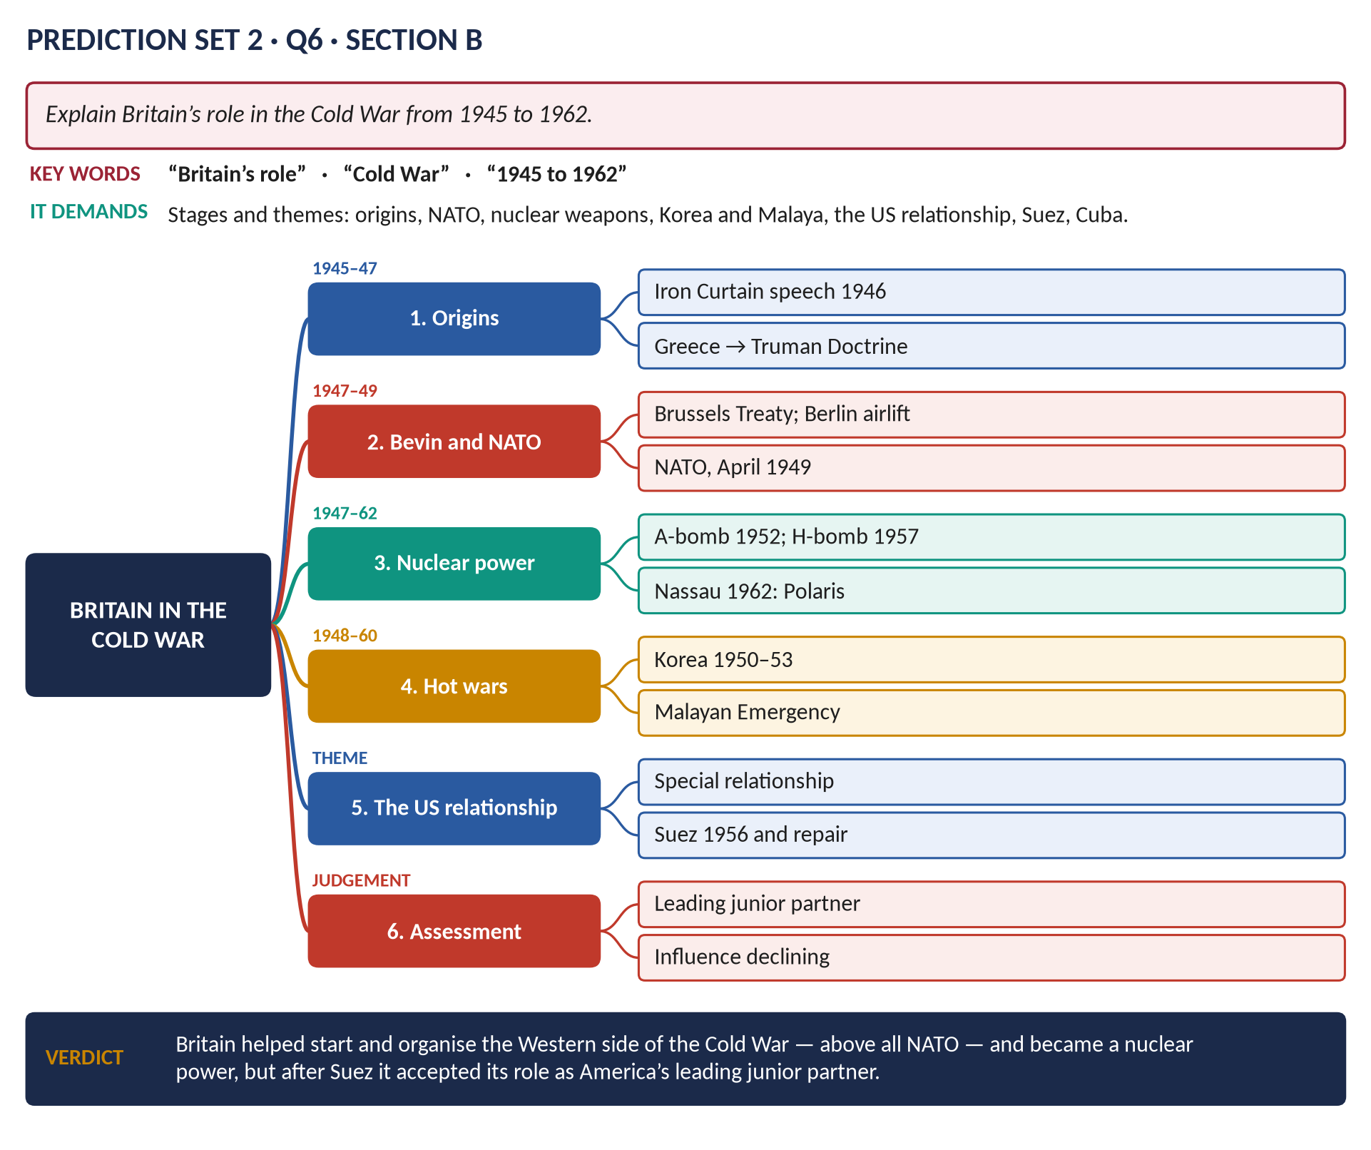
Figure 11 · The answer map.
DECODING THE QUESTION
Explain Britain's role across the period — origins, alliances, nuclear weapons, wars, the US relationship — and assess its significance.

Key facts to deploy
- Origins: Churchill's Iron Curtain speech (Fulton, 5 March 1946); Britain handed Greece and Turkey to the USA (February 1947) → the Truman Doctrine; Bevin and the Marshall Plan.
- Alliances: the Treaty of Dunkirk (1947); the Brussels Treaty (1948); the Berlin Airlift (1948–49); NATO (4 April 1949).
- Nuclear: the atomic bomb (1952); the H-bomb (1957); the 1958 Mutual Defence Agreement; the Nassau Agreement (1962) — Polaris.
- Wars and emergencies: Korea (1950–53; about 1,100 British dead); the Malayan Emergency (1948–60).
- The US relationship: the special relationship; Suez (1956) as a lesson; Macmillan's repair; the Cuban missile crisis (1962).
- Verdict: a founder of the Western alliance; after Suez, America's leading junior partner.
- Revise: T8KB Chapter 6.

Q7 · Why Britain Voted to Leave the EU
THE QUESTION · Prediction Set 2 · Q7 · Section B · 20 marks
Why did Britain vote to leave the European Union in 2016?

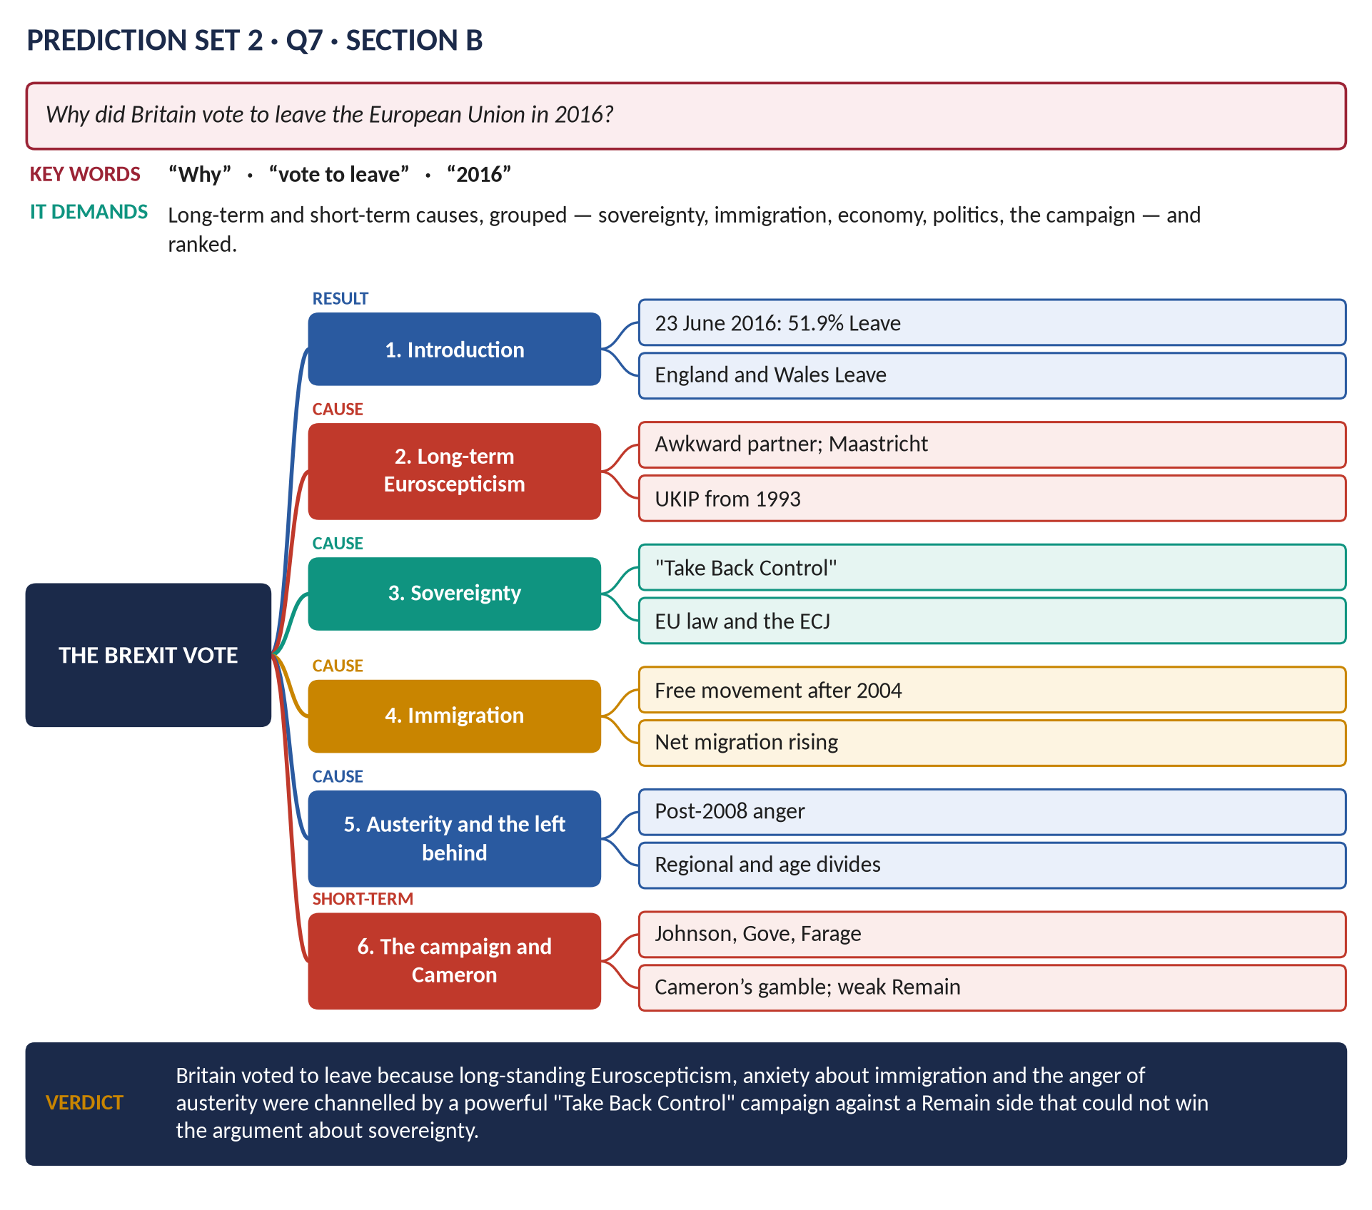
Figure 12 · The answer map.
DECODING THE QUESTION
Why = causes, long-term and short-term, grouped and ranked.

Key facts to deploy
- Result: 23 June 2016 — 51.9 per cent Leave; turnout 72 per cent; England and Wales Leave; Scotland and Northern Ireland Remain.
- Long-term Euroscepticism: the "awkward partner"; Maastricht rebels; UKIP (1993) — first in the 2014 European elections.
- Sovereignty: "Take Back Control"; EU law and the ECJ (Factortame, 1990).
- Immigration: free movement after 2004; net migration over 300,000 a year.
- Austerity and the "left behind": post-2008 anger; research linking cuts to Leave votes; age, education and regional divides.
- The campaign: Vote Leave (Johnson, Gove, Cummings); the £350 million claim; Farage; a weak, economic Remain campaign ("Project Fear").
- Cameron: the Bloomberg speech (2013); a thin renegotiation (February 2016).
- Revise: T10KB Chapter 5; T9KB Chapter 4.

Q8 · Short Notes — Key Facts

(a) The Battle of Britain
July–October 1940: after the fall of France, the Luftwaffe tried to destroy the RAF to prepare Operation Sea Lion (invasion). Fighter Command (Dowding), radar (the Chain Home stations), the Spitfire and Hurricane, and pilots from Britain, the Commonwealth, Poland and Czechoslovakia won. The switch to bombing London (7 September) relieved the airfields; 15 September "Battle of Britain Day". Churchill: "Never in the field of human conflict was so much owed by so many to so few" (20 August). Hitler postponed the invasion — Britain survived to be the base for D-Day. (T8KB Chapter 1.)

(b) The Miners' Strike of 1984–85
March 1984 – March 1985; the National Coal Board planned about 20 pit closures; the NUM under Arthur Scargill struck without a national ballot — Nottinghamshire miners kept working; coal stocks and national policing prepared by the government; the "Battle of Orgreave" (June 1984); Thatcher's "enemy within"; the miners returned defeated; pit closures followed — about 170 pits in 1984, almost none by the 1990s; union power broken; mining communities devastated. (T9KB Chapter 1.)

(c) Robert Owen (1771–1858)
Welsh-born mill owner; manager of New Lanark mills (from 1800) — decent housing, schools, shorter hours, no young children at work, yet profitable; A New View of Society (1813): character formed by environment; campaigned for the Factory Act (1819); founded New Harmony, Indiana (1825); the Grand National Consolidated Trades Union (1834); inspired the co-operative movement (Rochdale Pioneers, 1844); the "father of British socialism". (T4KB Chapter 6.)

Prediction Set 3
NOTE · Instructions
Time allowed: 3 hours. Part I (MCQs) 30 minutes; Part II 2 hours 30 minutes. Maximum marks: 100. Attempt FOUR questions in Part II, selecting TWO from each Section. All Part II questions carry 20 marks.

Part I · Question 1 — MCQs (20 marks)
1. The Act of Union between England and Scotland was passed in: (A) 1603 · (B) 1707 · (C) 1688 · (D) None of these
2. The War of the Spanish Succession was ended by the Treaty of: (A) Utrecht · (B) Ryswick · (C) Paris · (D) None of these
3. The first Hanoverian king of Great Britain was: (A) George II · (B) William III · (C) George III · (D) None of these
4. The Jacobite rising of 1745 was finally defeated at: (A) Preston · (B) Sheriffmuir · (C) Culloden · (D) None of these
5. General Wolfe captured Quebec in: (A) 1759 · (B) 1756 · (C) 1763 · (D) None of these
6. The slave trade was abolished in the British Empire in: (A) 1833 · (B) 1838 · (C) 1807 · (D) None of these
7. The Wealth of Nations (1776) was written by: (A) Jeremy Bentham · (B) Adam Smith · (C) John Stuart Mill · (D) None of these
8. The leader of the "physical force" Chartists was: (A) William Lovett · (B) Robert Owen · (C) Francis Place · (D) None of these
9. "My mission is to pacify Ireland" was said by: (A) Peel · (B) Disraeli · (C) Gladstone · (D) None of these
10. Queen Victoria became Empress of India in: (A) 1876 · (B) 1858 · (C) 1901 · (D) None of these
11. The Fabian Society was founded in: (A) 1893 · (B) 1884 · (C) 1900 · (D) None of these
12. The Anglo-Japanese Alliance was signed in: (A) 1894 · (B) 1907 · (C) 1902 · (D) None of these
13. The "war guilt" clause of the Treaty of Versailles was Article: (A) 231 · (B) 16 · (C) 10 · (D) None of these
14. Women first voted on equal terms with men after the Act of: (A) 1918 · (B) 1945 · (C) 1928 · (D) None of these
15. The Atlantic Charter (1941) was agreed by Churchill and: (A) Stalin · (B) Truman · (C) de Gaulle · (D) None of these
16. The Beveridge Report was published in: (A) 1942 · (B) 1939 · (C) 1945 · (D) None of these
17. The "wind of change" speech (1960) was made by: (A) Attlee · (B) Eden · (C) Macmillan · (D) None of these
18. Margaret Thatcher resigned as Prime Minister in: (A) 1987 · (B) 1992 · (C) 1990 · (D) None of these
19. The Maastricht Treaty created: (A) the European Economic Community · (B) EFTA · (C) the Council of Europe · (D) None of these
20. The United Kingdom formally left the European Union on: (A) 23 June 2016 · (B) 29 March 2019 · (C) 31 January 2020 · (D) None of these

Part II · Section A (attempt any TWO)
Q2. Discuss the causes and consequences of the Act of Union of 1707 between England and Scotland. (20)
Q3. Examine Britain's role in the defeat of Napoleon. (20)
Q4. Assess Disraeli's contribution to the Conservative Party and to social reform. (20)
Q5. Discuss the causes of the Scramble for Africa and Britain's role in it. (20)

Part II · Section B (attempt any TWO)
Q6. Discuss the role of the Second World War conferences in shaping the post-war world, and the creation of the United Nations. (20)
Q7. Assess the significance of devolution and the Good Friday Agreement for the United Kingdom. (20)
Q8. Write short notes on any TWO of the following: (10 each)
(a) Black Wednesday (1992) · (b) The Seven Years' War · (c) Covid-19 and British politics

Set 3 · Answer Key — Part I
No. | Answer | Why
1 | B | In force 1 May 1707.
2 | A | Utrecht, 1713.
3 | D | George I (1714).
4 | C | Culloden, 16 April 1746.
5 | A | September 1759 — the "year of victories".
6 | C | The Abolition of the Slave Trade Act, 1807.
7 | B | Adam Smith.
8 | D | Feargus O'Connor.
9 | C | Gladstone, 1868.
10 | A | The Royal Titles Act, 1876.
11 | B | January 1884.
12 | C | 30 January 1902.
13 | A | Article 231.
14 | C | The Equal Franchise Act, 1928 (first used in 1929).
15 | D | Franklin D. Roosevelt.
16 | A | 1 December 1942.
17 | C | Macmillan, Cape Town, 3 February 1960.
18 | C | 22 November 1990 (Major took over on 28 November).
19 | D | The European Union (1993).
20 | C | 31 January 2020.

Set 3 · Answer Maps and Outlines

Q2 · The Act of Union, 1707
THE QUESTION · Prediction Set 3 · Q2 · Section A · 20 marks
Discuss the causes and consequences of the Act of Union of 1707 between England and Scotland.

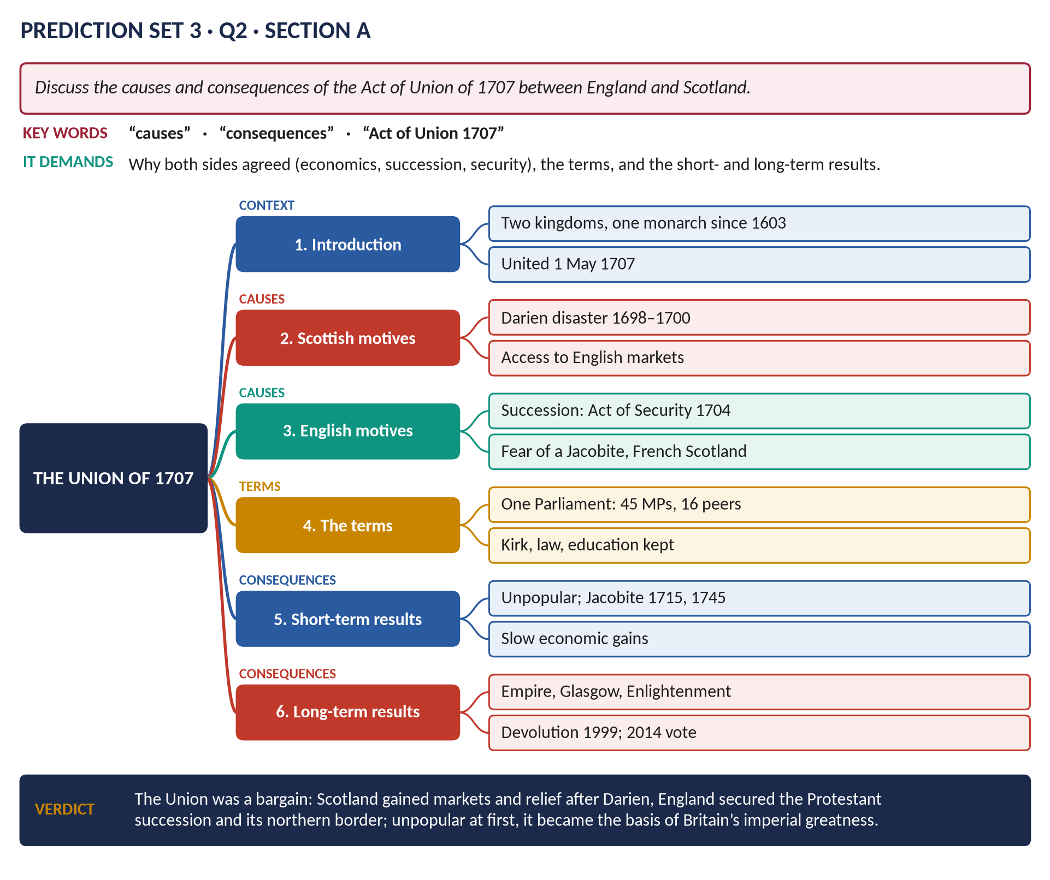
Figure 13 · The answer map.
DECODING THE QUESTION
Causes on both sides, the terms, and consequences — short-term and long-term (to devolution and 2014).

Key facts to deploy
- Background: one monarch since 1603, two parliaments, two economies.
- Scottish motives: the failure of the Darien scheme (1698–1700) cost perhaps a quarter of Scotland's capital; access to English and colonial markets; the promise of the Equivalent (about £398,000).
- English motives: the succession — the Scottish Act of Security (1704) threatened a different monarch; the English Alien Act (1705) retaliated; fear of a Jacobite, pro-French Scotland during the war with France.
- Terms: one Parliament of Great Britain — 45 Scottish MPs and 16 peers; free trade; common taxes and currency; the Presbyterian Kirk, Scots law and education preserved; in force 1 May 1707.
- Short-term: unpopular ("bought and sold for English gold" — Burns); the malt tax riots; Jacobite risings (1715, 1745).
- Long-term: Glasgow's tobacco trade; Scots in the Empire; the Scottish Enlightenment; devolution (1999); the independence referendum (2014: 55% No).
- Revise: T1KB.

Q3 · Britain and the Defeat of Napoleon
THE QUESTION · Prediction Set 3 · Q3 · Section A · 20 marks
Examine Britain's role in the defeat of Napoleon.

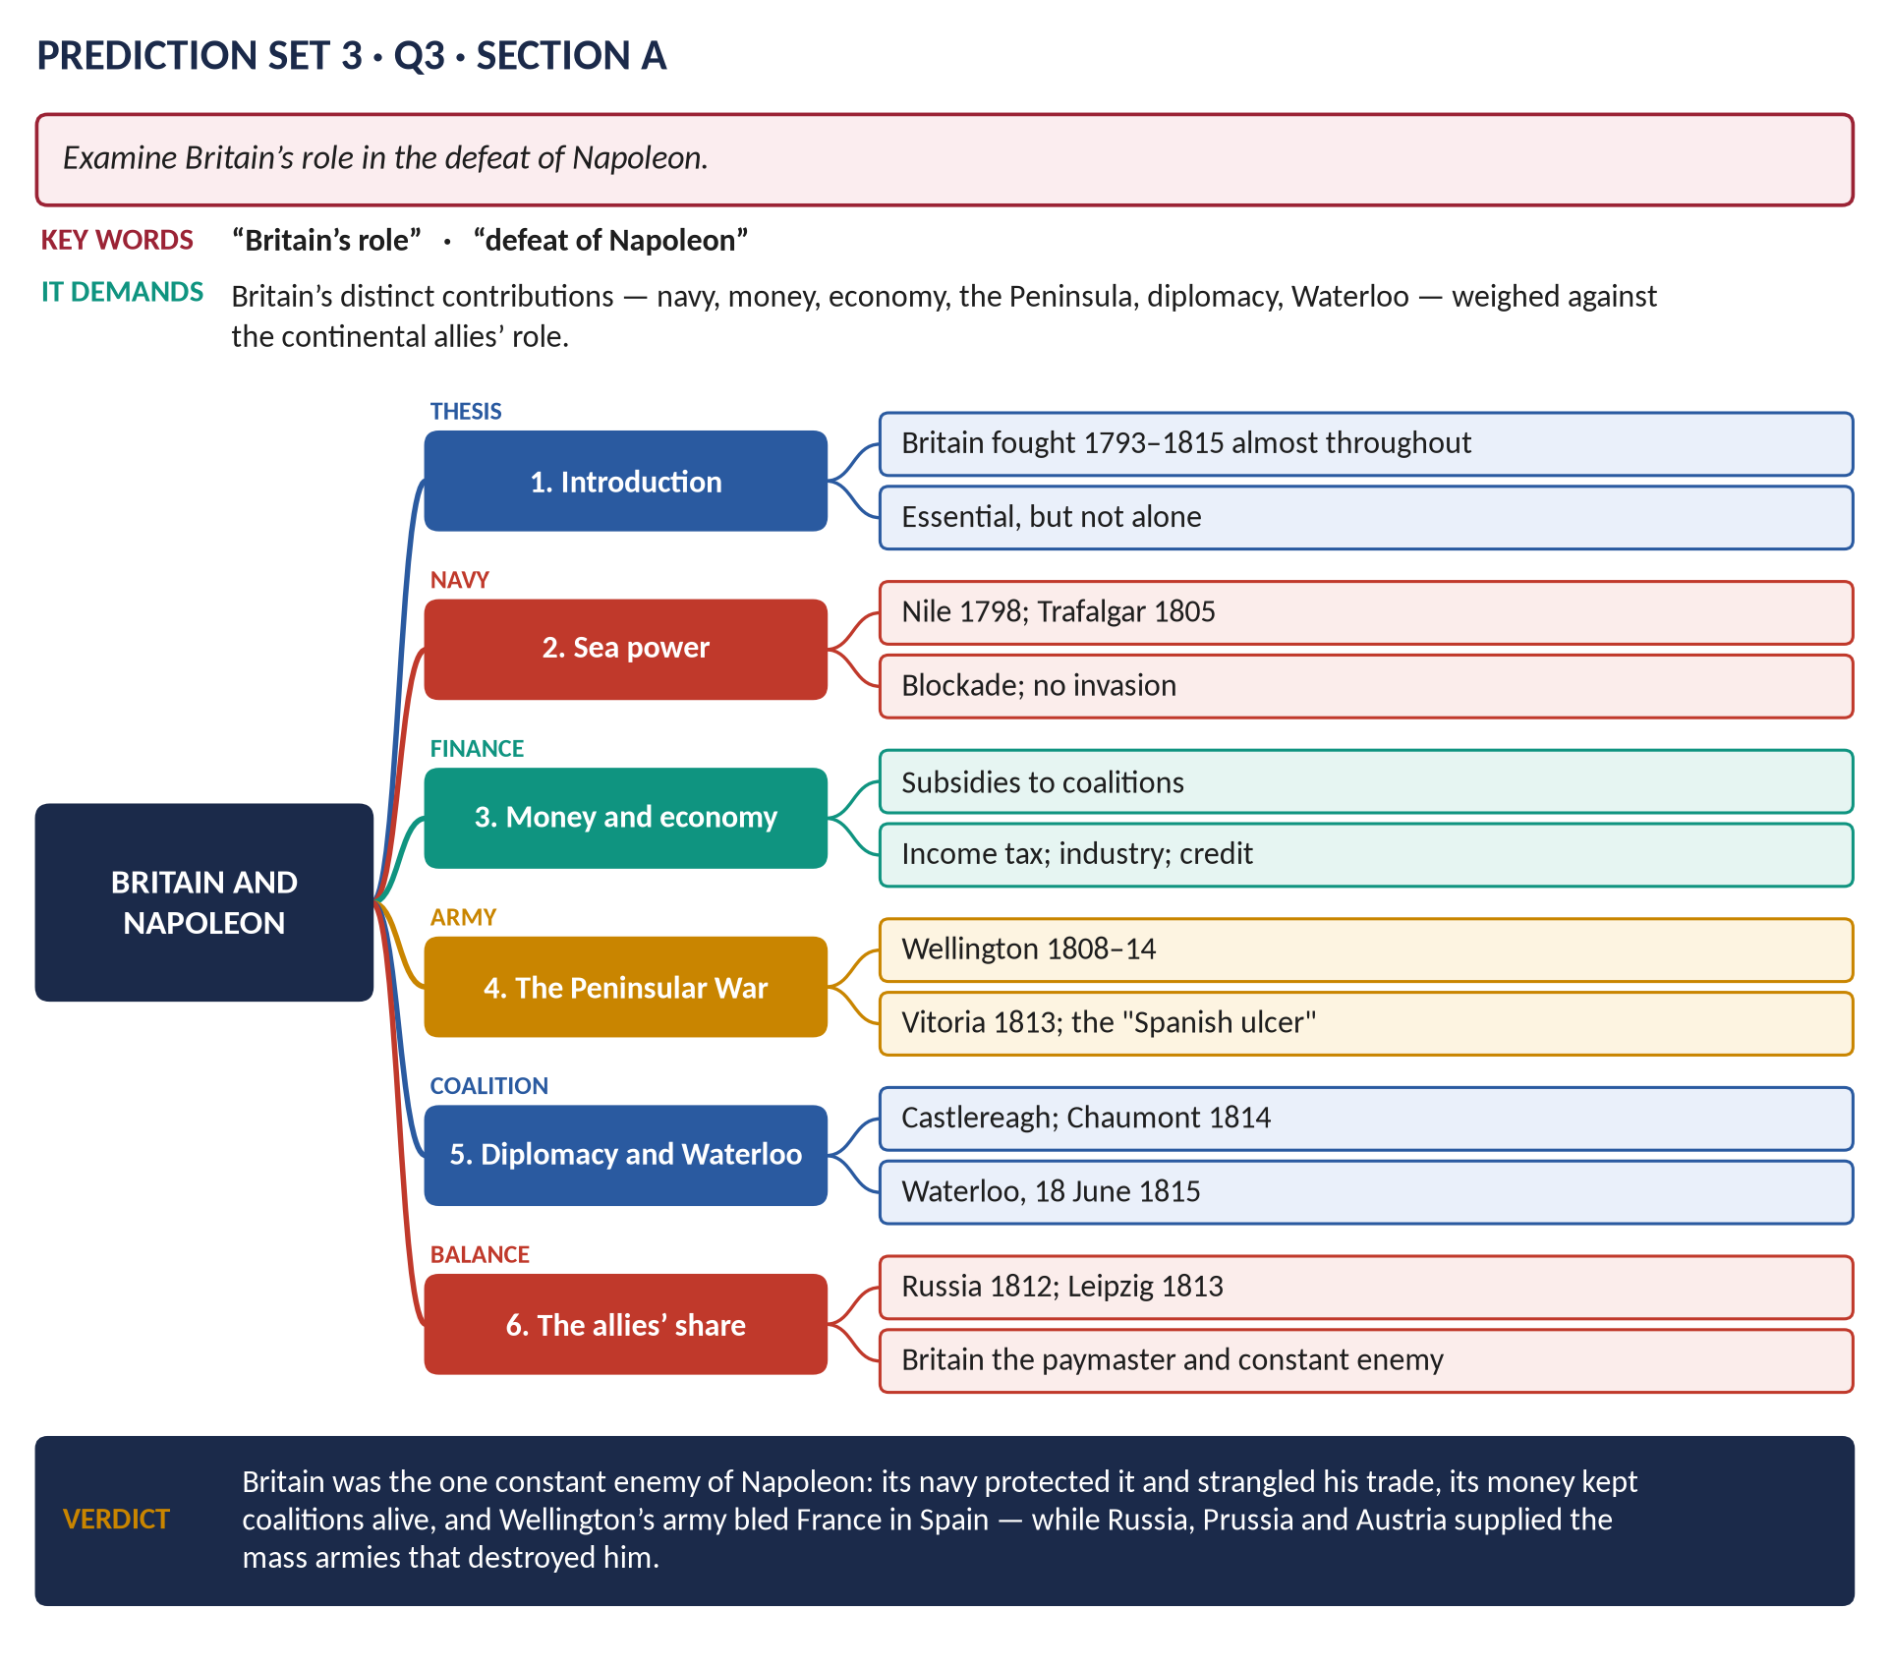
Figure 14 · The answer map.
DECODING THE QUESTION
Examine Britain's distinct contributions — and weigh them against those of Russia, Prussia and Austria.

Key facts to deploy
- Sea power: the Nile (1798); Trafalgar (21 October 1805) ended the invasion threat; blockade of French ports; colonies seized.
- Economic war: Napoleon's Continental System (Berlin Decrees, 1806) v British Orders in Council (1807); British trade survived; Russia's break with the System (1810) led to 1812.
- Money: subsidies to allies ("Pitt's gold"); income tax (1799); industry and credit.
- The Peninsular War (1808–14): Wellington; Talavera, Salamanca (1812), Vitoria (1813); the "Spanish ulcer" tied down 250,000 French troops.
- Diplomacy: Castlereagh and the Treaty of Chaumont (1814).
- Waterloo (18 June 1815) with Blücher's Prussians.
- Allies' role: Russia (1812), Leipzig (1813) — the mass armies.
- Revise: T3KB.

Q4 · Disraeli: Party and Social Reform
THE QUESTION · Prediction Set 3 · Q4 · Section A · 20 marks
Assess Disraeli's contribution to the Conservative Party and to social reform.

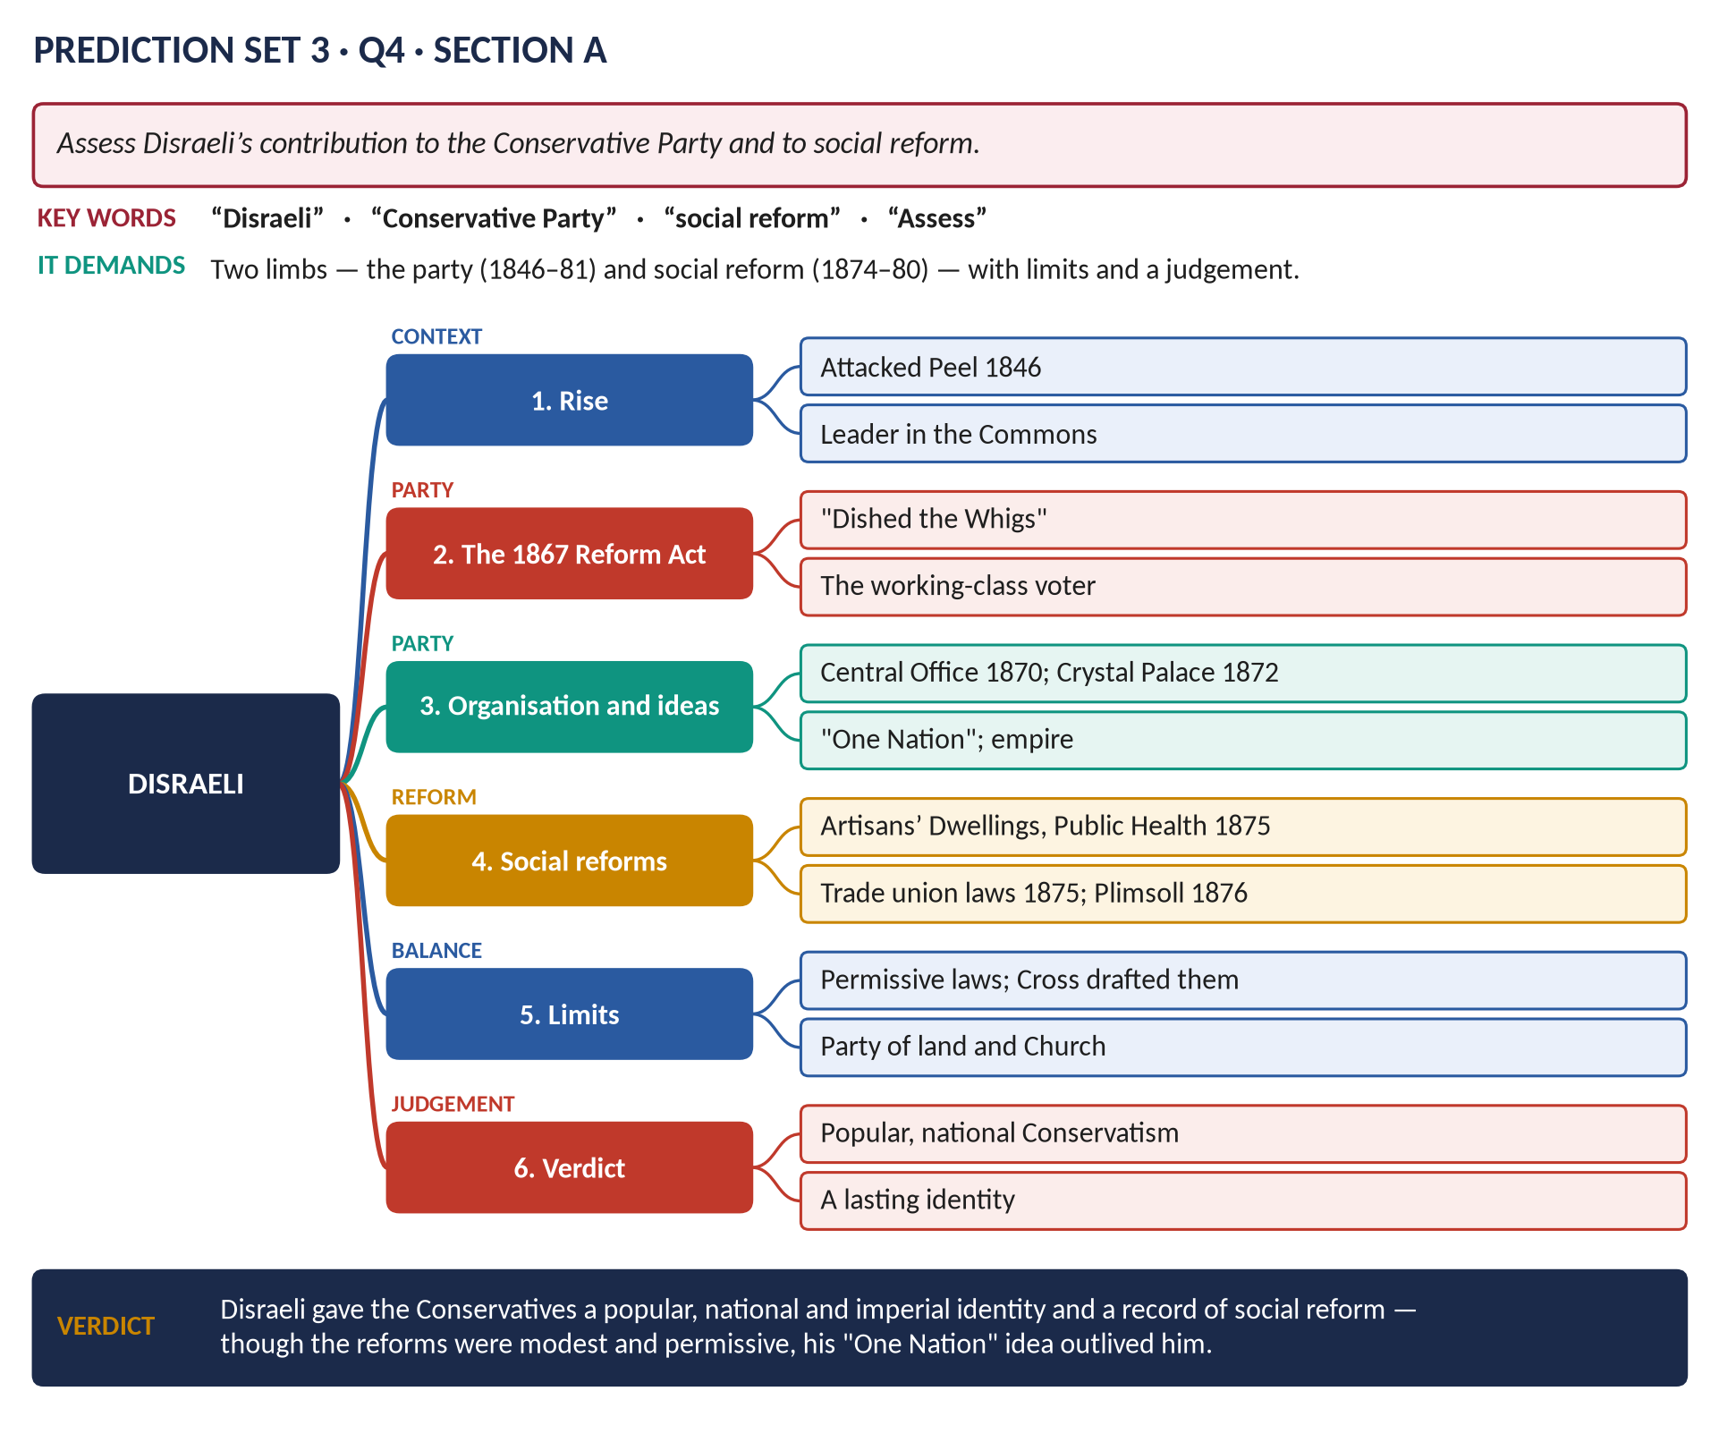
Figure 15 · The answer map.
DECODING THE QUESTION
Two limbs — the party and social reform — with limits, and a judgement of his importance.

Key facts to deploy
- Rise: attacked Peel over the Corn Laws (1846); leader in the Commons; Chancellor in Derby's governments.
- The Second Reform Act (1867): "dished the Whigs"; urban working men enfranchised.
- The party: the National Union (1867); Conservative Central Office (1870, John Gorst); the Manchester and Crystal Palace speeches (1872) — institutions, empire, the condition of the people; "One Nation"; the 1874 majority; the Primrose League (1883) in his memory.
- Social reforms (1874–80, with Richard Cross): the Artisans' Dwellings Act (1875), the Public Health Act (1875), the Sale of Food and Drugs Act (1875), the Conspiracy and Protection of Property Act (1875) — peaceful picketing legal; the Employers and Workmen Act (1875); the Merchant Shipping Act (1876, the Plimsoll line); the Factory Act (1878); the Education Act (1876).
- Limits: many Acts were permissive; drafted by Cross; Disraeli's interest was more in empire and foreign affairs.
- Revise: T5KB Chapter 6.

Q5 · The Scramble for Africa
THE QUESTION · Prediction Set 3 · Q5 · Section A · 20 marks
Discuss the causes of the Scramble for Africa and Britain's role in it.

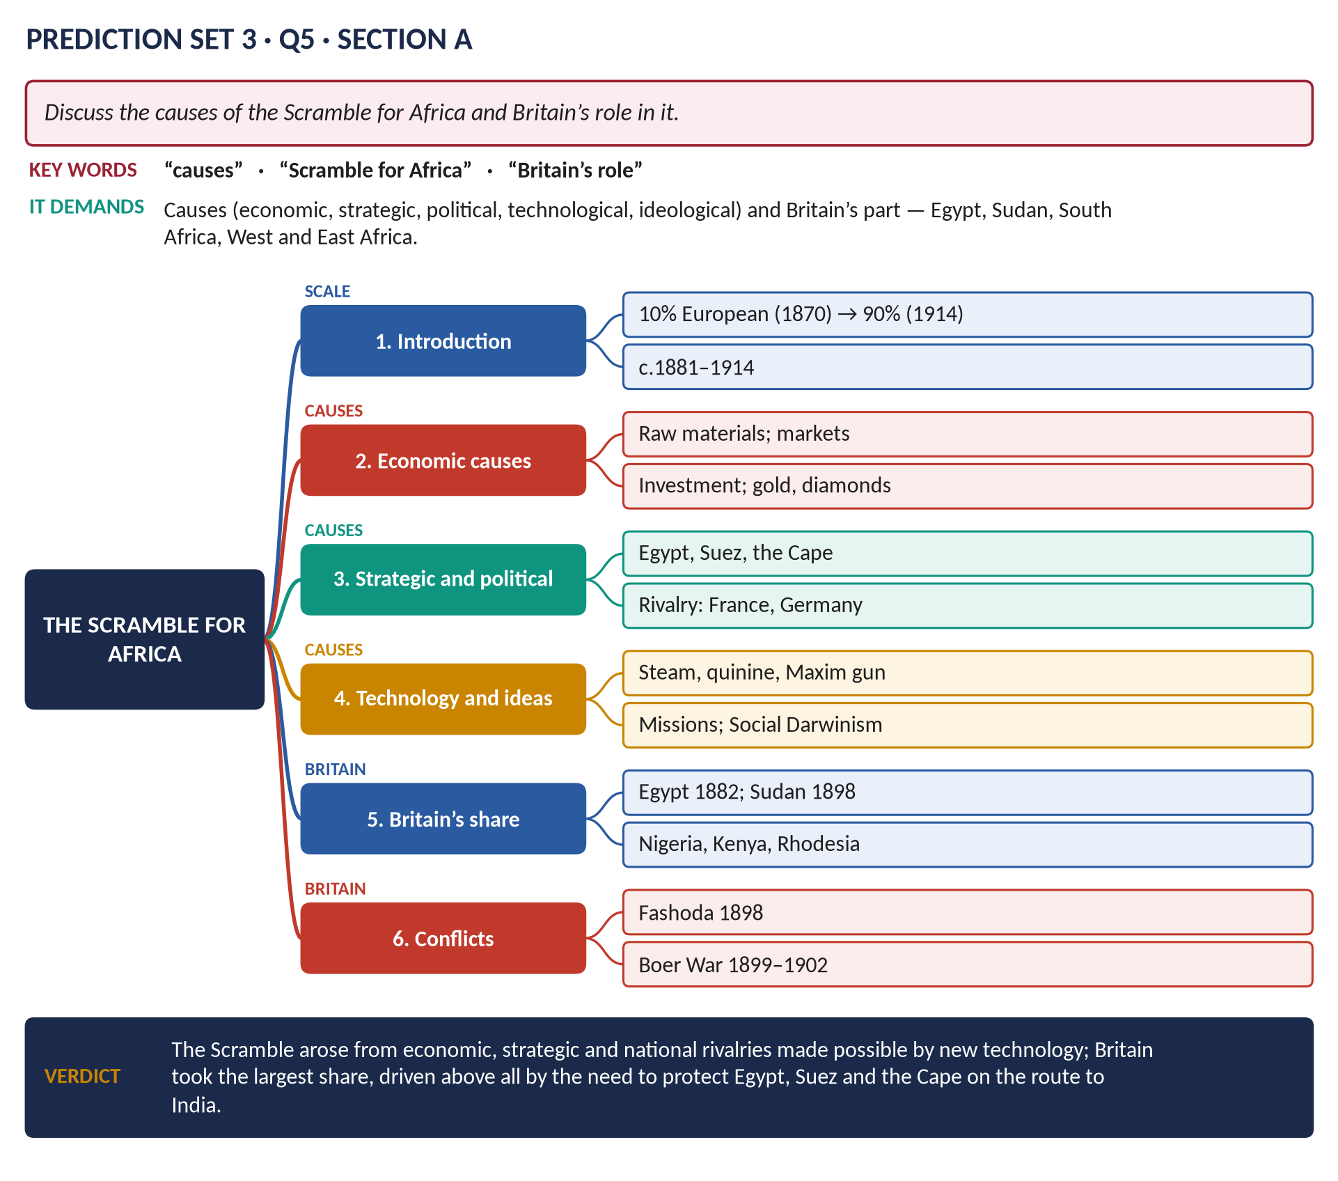
Figure 16 · The answer map.
DECODING THE QUESTION
Causes (grouped) and Britain's role — where, why, and the conflicts it caused.

Key facts to deploy
- Scale: Europeans held about 10 per cent of Africa in 1870 and about 90 per cent by 1914.
- Causes: raw materials and markets; investment; strategic (Egypt, Suez, the Cape — the route to India); rivalry and prestige (Germany, France, Italy, Belgium); technology (steamships, railways, quinine, the Maxim gun); ideas (missionaries, the "civilising mission", Social Darwinism); the Berlin Conference (1884–85).
- Britain: Egypt (1882); the Sudan (Gordon 1885; Omdurman 1898); Nigeria, the Gold Coast; Kenya, Uganda; Rhodesia (Rhodes, 1889); "Cape to Cairo".
- Conflicts: Fashoda (1898); the Boer War (1899–1902).
- Historians: Robinson and Gallagher — strategy (the route to India) more than economics.
- Revise: T6KB Chapter 6.

Q6 · The War Conferences and the United Nations
THE QUESTION · Prediction Set 3 · Q6 · Section B · 20 marks
Discuss the role of the Second World War conferences in shaping the post-war world, and the creation of the United Nations.

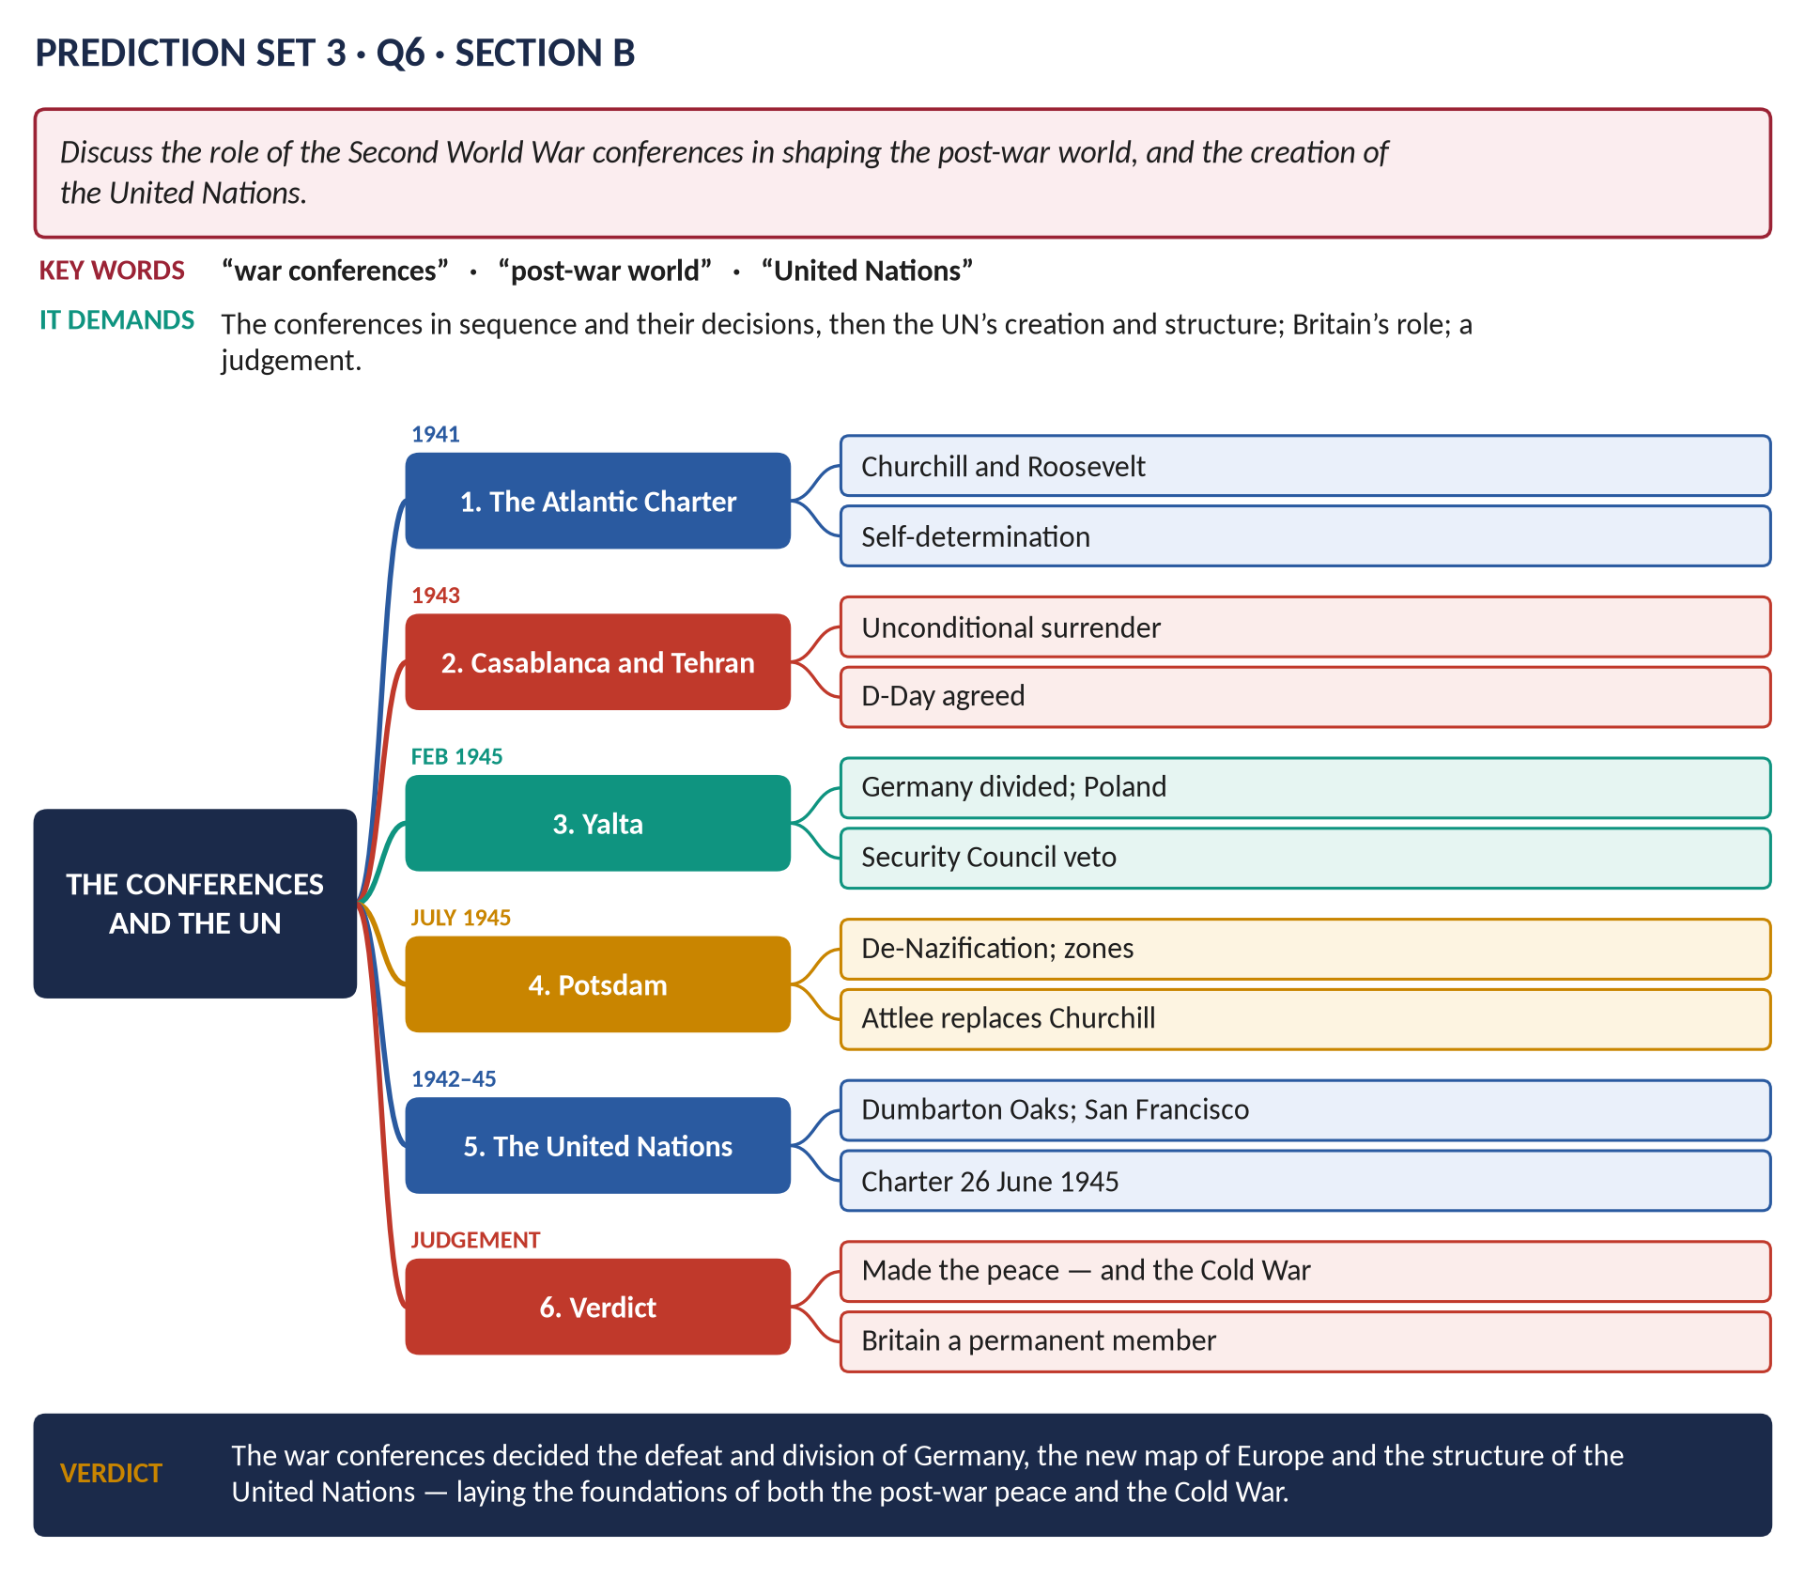
Figure 17 · The answer map.
DECODING THE QUESTION
The conferences in sequence and their decisions; then the UN's creation and structure; Britain's part; a judgement.

Key facts to deploy
- Atlantic Charter (14 August 1941): self-determination, no territorial gains, a system of security.
- Arcadia (Washington, 1941–42): "Germany first"; the Declaration by United Nations (1 January 1942).
- Casablanca (January 1943): unconditional surrender. Tehran (November 1943): the Big Three; D-Day agreed.
- Bretton Woods (1944): IMF, World Bank. Dumbarton Oaks (1944): the UN plan. Moscow (October 1944): the percentages agreement.
- Yalta (February 1945): Germany divided; Poland; the Security Council veto; the USSR to fight Japan.
- Potsdam (July–August 1945): de-Nazification; zones; Attlee replaced Churchill.
- San Francisco: the UN Charter (26 June 1945); UN born 24 October 1945; the five permanent members.
- Verdict: the conferences made the peace — and the Cold War division of Europe; Britain a permanent member.
- Revise: T8KB Chapter 3.

Q7 · Devolution and the Good Friday Agreement
THE QUESTION · Prediction Set 3 · Q7 · Section B · 20 marks
Assess the significance of devolution and the Good Friday Agreement for the United Kingdom.

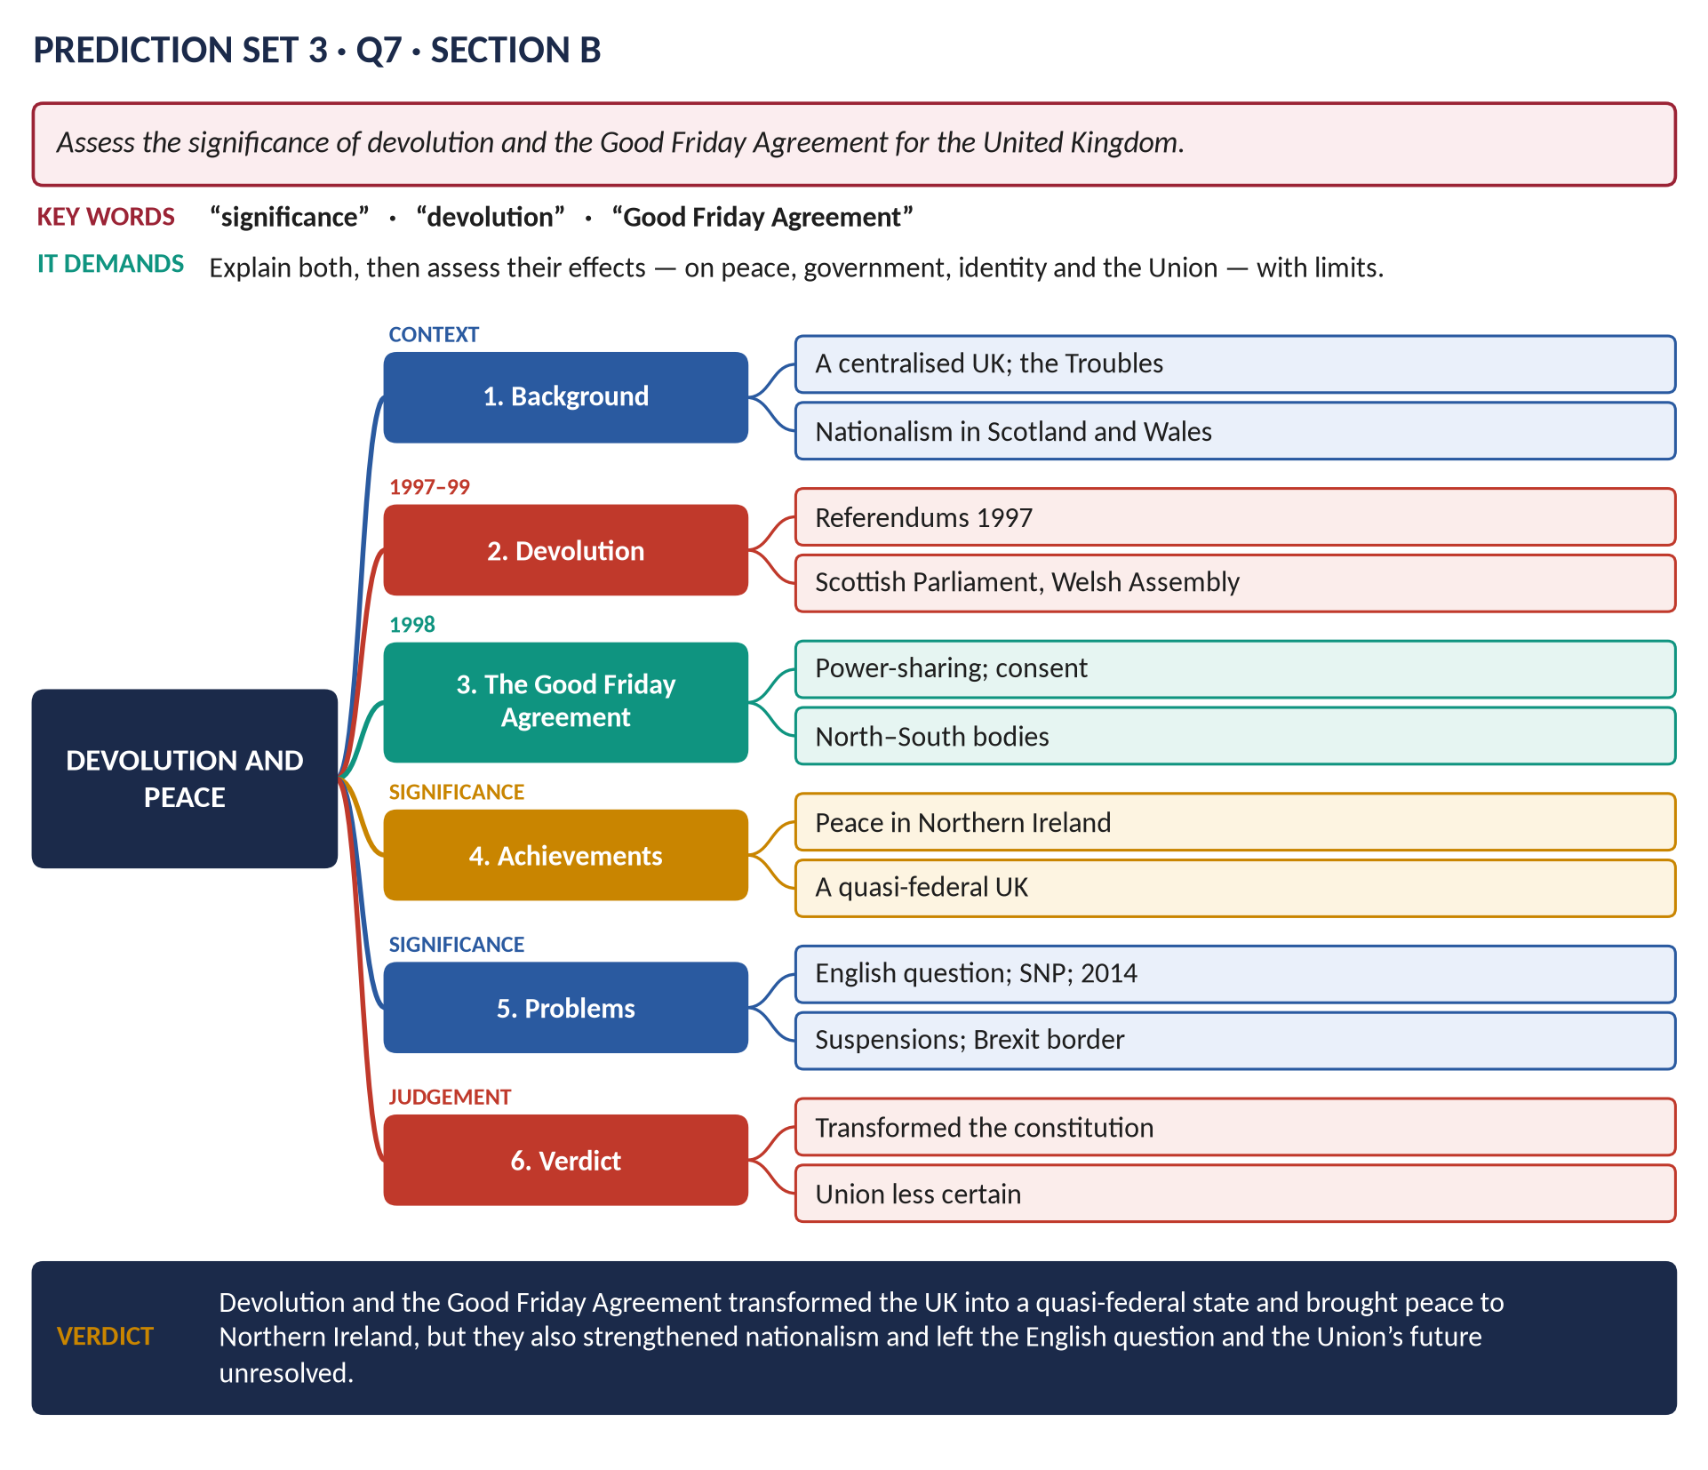
Figure 18 · The answer map.
DECODING THE QUESTION
Explain both, then assess significance — peace, government, identity, the Union — with problems and limits.

Key facts to deploy
- Devolution: referendums (September 1997); the Scottish Parliament and Welsh Assembly (1999); the Mayor of London (2000); later powers (Scotland Acts 2012, 2016; Wales 2014, 2017).
- The Good Friday Agreement (10 April 1998): power-sharing Assembly and Executive; the principle of consent; North–South and British–Irish bodies; prisoner releases; decommissioning; referendums in both parts of Ireland (May 1998).
- Achievements: peace in Northern Ireland; a quasi-federal UK; policy divergence (free university tuition in Scotland).
- Problems: the English question; the rise of the SNP (2007, 2011) → the 2014 referendum (55.3% No); suspensions of Stormont (2002–07, 2017–20, 2022–24); Brexit and the Irish border (the Windsor Framework, 2023).
- Revise: T10KB Chapters 1 and 8.

Q8 · Short Notes — Key Facts

(a) Black Wednesday (1992)
16 September 1992: Britain had joined the ERM (October 1990) at about 2.95 German marks to the pound; high German interest rates and speculators (George Soros) forced the pound down; Norman Lamont raised interest rates from 10 to 12 and then 15 per cent in one day and spent billions of reserves, but Britain left the ERM that evening; cost to the Treasury about £3.3 billion. Results: the Conservatives' reputation for economic competence destroyed (contributing to 1997); inflation targeting introduced; a strong recovery followed; Euroscepticism grew; the euro became politically impossible. (T9KB Chapter 3.)

(b) The Seven Years' War (1756–1763)
Britain and Prussia against France, Austria and Russia (and Spain from 1762); a world war fought in Europe, North America, India and at sea; led by Pitt the Elder; 1759 the "year of victories" — Quebec (Wolfe), Minden, Lagos, Quiberon Bay; Plassey (1757, Clive) in India. Treaty of Paris (1763): Britain gained Canada, Florida and supremacy in India. Results: Britain the leading colonial power; a huge debt — taxes on the American colonies → the American Revolution. (T2KB.)

(c) Covid-19 and British politics
First UK cases January 2020; the first lockdown (23 March 2020); the furlough scheme (about 11.7 million jobs supported); record borrowing; the world's first approved vaccine (2 December 2020; first jab 8 December); about 230,000 deaths with Covid on the death certificate; "partygate" — lockdown parties in Downing Street — contributed to Boris Johnson's fall (2022); the UK Covid-19 Inquiry (from 2022) criticised pandemic preparedness (2024). Effects: debt near 100 per cent of GDP; learning loss; NHS waiting lists; inequality. (T10KB Chapter 7.)

